REPUBLIC OF UZBEKISTAN HIGH AND SECONDARY
MINISTRY OF SPECIAL EDUCATION

GULISTON STATE UNIVERSITY

NORMURODOV OYBEK BERDIMUROD O‘G‘LI

PERSIAN LANGUAGE
educational content from science

60211400 – Vocal art (traditional singing)

Gulistan - 2025

Normurodov Oybek Berdimurod o‘g‘li. Persian language. Educational content. Gulistan, – 2025. – B. 20.

This content was prepared according to the “Persian language” science program of the 60211400 – Vocal art (traditional singing).
This content provides a clear introduction to Persian subject pronouns, covering their singular and plural forms and their short (unstressed) variants commonly used in everyday speech. It outlines the main types of pronouns in Persian, with special attention to demonstrative pronouns such as این and آن, which indicate proximity or distance, and interrogative pronouns like چه and کی, used for forming questions. The material is designed for beginner learners, helping them recognize, differentiate, and correctly use these pronoun categories in simple sentences, building a solid foundation for Persian grammar and communication.
The content is intended for students, graduate students of Vocal art (traditional singing) and researchers conducting scientific research in this field.

Responsible editor
A.Muratkulov

Reviewers
S.Mamarakhimov

1.Topic.
PRONOUNS IN PERSIAN. TYPES OF PRONOUNS. DEMONSTRATION PRONOUNS AND INTERROGATIVE PRONOUNS.

PLAN:
- Pronouns in persian.
- Types of pronouns: demonstration pronouns and interrogative pronouns.

Basic words and phrases: Subject Pronouns, singular forms, plural forms, short, persian, types of pronouns, demonstration pronouns, interrogative pronouns.

- Grammar Lessons
English:
There are the following types of pronouns in Persian:
a) Subject Pronouns;
b) Demonstrative pronouns;
c) Interrogative pronouns.

Uzbek:
Fors tilida olmoshning quyidagi turlari mavjud:
- Kishilik olmoshlari;
- Ko‘rsatish olmoshlari;
- So‘roq olmoshlari.

Persian:
ضمایر در زبان فارسی به چند دسته تقسیم می‌شوند:
الف) ضَمیرهایِ فاعِلی؛
ب) ضمایر اشاره؛
ج) ضمایر پرسشی

- Grammar Lessons
ضَمیرهایِ فاعِلی مُفرَد
English: In Persian, Subject Pronouns refer to individuals and have both singular and plural forms.
Uzbek: Fors tilida kishilik olmoshlari shaxsga ishora qiladi va ular birlik va ko‘plik shakliga ega.
Persian: در زبان فارسی، ضَمیرهایِ فاعِلی مُفرَد به افراد اشاره دارند و هم شکل مفرد و هم شکل جمع دارند
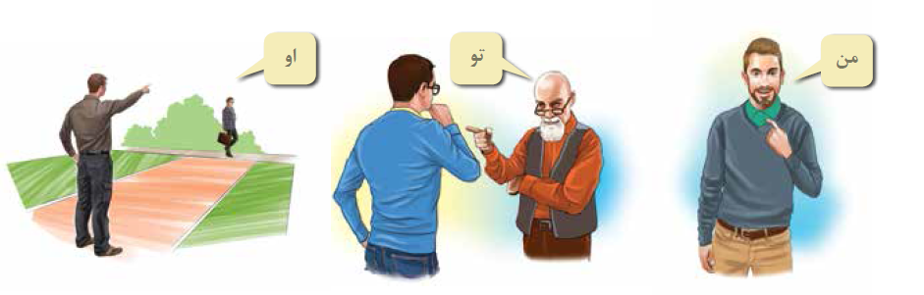
مَتنهای زیر را بخِوانید.

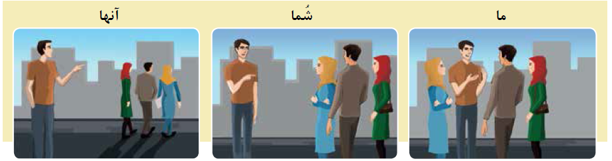

English: Compare the singular and plural forms of Subject Pronouns in English, Persian, and Uzbek in the table below:
Uzbek: Jadvalda keltirilgan ingliz, fors va o‘zbek tilidagi kishilik olmoshlarining birlik forma hamda ko‘plik formadagi shaklini qiyoslang:
Persian: ضَمیرهایِ فاعِلی را در جدول مقایسه کنید

Singular | Eng | Pers | Uzb | Plural | Eng | Pers | Uzb
I | I | مَن | Men | I | We | ما | Biz
II | You | تو | Sen | II | You | شُما | Siz
III | He/She | او | U | III | They | آنها – ايشان | Ular

- Introduce yourself: Where are you from?
- Read the text and mark the Subject Pronouns.

لهجه
نيما: سلام خانم. اسم من نيماست. اسم شماچيست؟
سيما: سلام. اسم من سيماست.
نيما: خوشوقتم.
سيما: من هم همينطور. شما كجايى هستيد؟
نيما: من اهل شيرازم. شما چطور؟
سيما: من تهرانى هستم ولى پدرومادرم اصفهانى هستند.
نيما: ولى شما لهجۀ اصفهانى نداريد.
سيما: شما هم همينطور.
نيما: لهجۀ اصفهانى؟
سيما: نه لهجۀ شيرازى!

The infinitive “to be” in English is equivalent to بودن in Persian. As “to be” changes its form completely when it is used with different pronouns, بودن also changes its form for different subjects. Furthermore, as “to be” has a contracted form in English, بودن can also be contracted:
بودن (to be)

Short Long

من خوشحال هستم. ← من خوشحالم.
تو خوشحال هستى. ← تو خوشحالى.
او خوشحال است. ← او خوشحال است.
ما خوشحال هستيم. ← ما خوشحاليم.
شما خوشحال هستيد. ← شما خوشحاليد.
آنها خوشحال هستند. ← آنها خوشحالند.
Short = Long

I’m happy. ← I am happy.
You’re happy. ← You are happy.
He’s happy. ← He is happy.
We’re happy. ← We are happy.
You’re happy. ← You are happy.
They’re happy. ← They are happy.

Negation
In Persian, the verb is negated with (ن) which is added to the beginning of the verb, and in compound verbs, to the beginning of the verbal part of the compound. For example:

I didn’t go to the university yesterday. = من ديروز به دانشگاه نرفتم.

We don’t live in Iran. = ما در ايران زندگى نمى كنيم

The negative form of the present tense of بودن is irregular:

Negative Positive

من دانشجو هستم. ← من دانشجو نيستم.
تو دانشجو هستى. ← تو دانشجو نيستى.
او دانشجواست. ← او دانشجو نيست.
ما دانشجو هستيم. ← ما دانشجو نيستيم.
شما دانشجو هستيد. ← شما دانشجو نيستيد.
آنها دانشجو هستند. ← آنها دانشجو نيستند

Positive Negative
I am a student. ← I am not a student.
You are a student. ← You are not a student.
He is a student. ← He is not a student.
We are students. ← We are not students.
You are students. ← You are not a student.
They are students. ← They are not students.

- Read the text and mark the Subject Pronouns.

من ايرانى هستم ولى در كانادا زندگى مى كنم
ايران كشورى قديمى است ولى كانادا كشور جديدى
است
. پدرومادرمن در ايران هستند ولى خواهر و برادر من در كانادا زندگى مى كنند.
من در دانشگاهى از قديمى ترين دانشگاه هاى كانادا است.

- Grammar Lessons

Questions جملۀ پرسشى

The word order of questions in Persian is the same as narrative sentences, i.e.: subject + object + verb.
To ask a yes/no question, either the tone is changed or the question word آيا is added to the beginning of the narrative sentence without making any other changes.
Adding آيا to the beginning of a question makes it formal.
For example:
آيا سام كتاب را دوست دارد؟
Does Sam like the book?

- Look at picture and mark the Interrogative pronouns

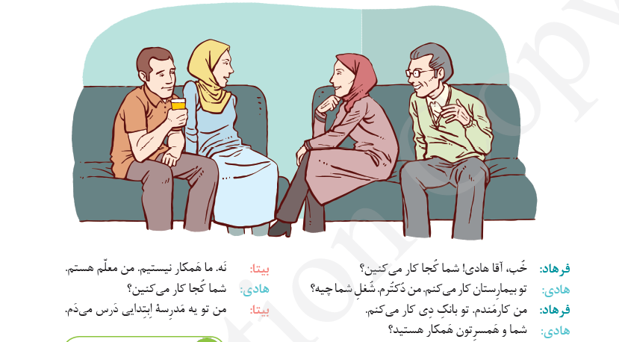

- Look at picture and mark the Interrogative pronouns

جملات زير را مرتب كنيد
شلوار-- پوشيدى -- قشنگى -- چه!
مى رود -- مدرسه -- او -- به -- كى؟
نوروز -- مى دانيد -- معنى -- آيا -- را؟
حرف مى زنيد -- چقدر -- فارسى -- خوب!
با -- سينما -- نمى آييد -- چرا -- ما -- به؟

- Grammar Lessons

Demonstrative pronouns ضمایر اشاره

In Persian, اين and آن are used before nouns as demonstrative adjectives. If the demonstrative is used before the noun, it always appears in the singular form, despite the number of the noun, e.g.:
these books اين كتاب ها ← this book اين كتاب
those woman آن زنان ← that woman آن زن
اين كتاب به فارسى است.
This book is in Persian.
اين كتابها به فارسى هستند.
These books are in Persian.
آن آقا ايرانى است.
That gentleman is Iranian.
آن آقايان ايرانى هستند.
Those gentlemen are Iranian.

The demonstratives اين ,آنها ,آن , and اينها can also be used on their own as pronouns, e.g.:
اين كتابِ جالبى است.
This is an interesting book.
اينها كتابهاى جالبى هستند.
These are interesting books.
آنها ماشين هاى ما هستند.
Those are our cars.
اينها لباس هاى قشنگى هستند.
These are beautiful dresses.

As a general rule, if the noun is indefinite, it takes the indefinite marker ى, and if it is definite, it does not have any marker, except for when it is an object, in which case, it akes the definite object marker را , e.g.:
I read a book. . من كتابى خواندم
I read the book. . من كتاب را خواندم
If the noun is modified by an adjective, either the noun or the adjective can take the indefinite marker ى, e.g.:
كتابى خوب
كتابِ خوبى

However, if there is more than one adjective, the indefinite marker ى is either added to the last adjective, or else the ى is added to the noun and the adjectives are combined with و . In phrases with definite nouns, the definite object marker را is added after the last
adjective, e.g.:
كتابِ خوبِ گرانى
a good, expensive book
كتابى خوب و گران
a good, expensive book
من اين شهر را ديده بودم.
I had seen this city.
من اين شهر زيبا را ديده بودم.
I had seen this beautiful city.
من اين شهر زيباى بزرگ را ديده بودم.
I had seen this big, beautiful city.

- Look at picture and mark the Demonstrative pronouns.

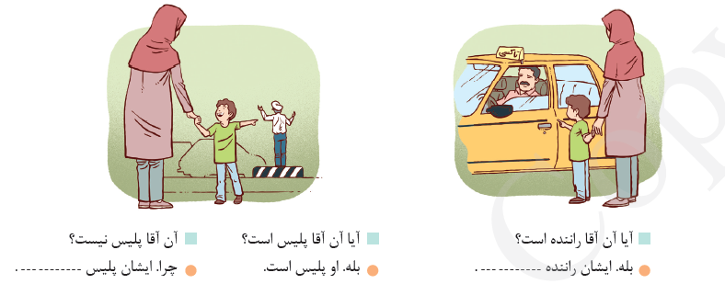

QUESTIONS:
1. Choose the correct pronoun that best completes the Persian sentence provided in the example below for you:
«این کتاب برای ___ است.»
2. Identify the proper pronoun that accurately fits the meaning of the Persian sentence shown directly underneath this question:
«من دیروز ___ را دیدم.»
3. Select the correct pronoun that logically completes the Persian sentence that appears below in the given example:
«او گفت که ___ فردا می‌آید.»
4.Choose the right pronoun that best matches the context expressed in the Persian example sentence written below here:
«این هدیه از طرف ___ بود.»
5.Determine the correct pronoun that appropriately fills the blank in the Persian sentence located directly under this instruction:
«ما منتظر ___ هستیم.»
6.Select the suitable pronoun that best completes the meaning intended in the Persian sample sentence written just below:
«دوست من ___ را به مهمانی دعوت کرد.»
7.Choose the correct pronoun that accurately expresses the intended reference inside the Persian sentence provided below this question:
«این خانه متعلق به ___ نیست.»
8.Identify the pronoun that logically completes the Persian sentence included immediately after this instruction given right here:
«استاد از ___ تشکر کرد.»
9.Choose the best pronoun that correctly completes the meaning of the Persian sentence placed directly beneath this question:
«او نمی‌دانست که ___ چه گفته است.»
10.Select the pronoun that most appropriately completes the Persian sentence appearing right after this instruction stated below:
«کتاب را به ___ دادم.»

TESTS
1. Choose the correct English pronoun for the underlined word.
او به مدرسه می‌رود.
a) He
b) They
c) We
d) I
2. Select the pronoun that best replaces the underlined word.
آن کتاب روی میز است.
a) She
b) It
c) You
d) They
3. Choose the correct object pronoun.
معلم به من کمک کرد.
a) him
b) us
c) me
d) her
4. Which pronoun correctly replaces the underlined noun?
مریم و علی در خانه هستند.
a) He
b) She
c) It
d) They
5. Choose the correct possessive pronoun.
این خانه مال ما است.
a) yours
b) ours
c) theirs
d) mine
6. Select the correct pronoun to complete the sentence.
او دوست دارد کتاب بخواند.
a) We
b) She
c) They
d) You
7. Choose the correct demonstrative pronoun.
این ماشین من است.
a) those
b) these
c) this
d) that
8. Select the correct plural pronoun.
آنها ورزش می‌کنند.
a) He
b) She
c) They
d) It
9. Choose the correct reflexive pronoun.
او خودش را در آینه دید.
a) herself
b) myself
c) ourselves
d) yourself
10. Choose the pronoun that fits the meaning.
آیا تو می‌توانی کمک کنی؟
a) I
b) He
c) You
d) We
11. Choose the correct subject pronoun.
من به بازار می‌روم.
a) He
b) I
c) They
d) She
12. Select the correct object pronoun.
کتاب را به او دادم.
a) them
b) her
c) us
d) you
13. Choose the correct pronoun to replace the underlined noun.
سگ در حیاط است.
a) They
b) You
c) It
d) We
14. Choose the correct possessive pronoun.
این گوشی مال تو است.
a) his
b) mine
c) yours
d) ours
15. Select the correct demonstrative pronoun.
آن‌ها دوستان من هستند.
a) this
b) that
c) these
d) those
16. Choose the correct pronoun for the sentence.
ما فوتبال بازی کردیم.
a) We
b) She
c) I
d) It
17. Select the correct object pronoun.
او مرا دید و به ما سلام کرد.
a) him
b) us
c) her
d) them
18. Choose the correct reflexive pronoun.
تو باید خودت را باور کنی.
a) myself
b) himself
c) yourself
d) themselves
19. Pick the correct pronoun.
آیا آن چیزی است که می‌خواهی؟
a) he
b) she
c) it
d) they
20. Select the best pronoun.
آنها به سفر رفتند.
a) He
b) They
c) We
d) You

GLOSSARY

ضمیر (Pronoun). A pronoun is a word used to replace a noun to avoid unnecessary repetition, simplify sentences, and make communication clearer and more efficient. Pronouns help speakers refer to people, objects, ideas, or previously mentioned things without constantly repeating their names. They create smoother language flow in both writing and speech. Without pronouns, sentences would sound heavy and unnatural. In Persian, the pronoun “او” can replace names like “علی” or “مریم” to avoid repetition. For example: «او آمد» instead of repeating a person’s full name.

ضمیر فاعلی (Subject Pronoun). A subject pronoun is used as the subject of a sentence and performs the action of the verb. It replaces a noun, making the sentence shorter and avoiding repetition. Common English subject pronouns include “I,” “you,” “he,” “she,” “it,” “we,” and “they.” They identify who or what is doing the action. Without these pronouns, sentences would become lengthy and repetitive. Subject pronouns are fundamental for constructing clear statements. In Persian, for example, “او می‌رود” uses “او” as a subject pronoun, replacing a person’s name while still keeping the meaning completely understandable.

ضمیر مفعولی (Object Pronoun). An object pronoun receives the action in a sentence or appears after a preposition. English examples include “me,” “you,” “him,” “her,” “us,” and “them.” These pronouns replace nouns and prevent unnecessary repetition, especially in daily conversation. They clarify who or what is affected by the action. Without object pronouns, many sentences would feel too long or unnatural. They are essential in both spoken and written communication. In Persian, “او مرا دید” uses “مرا” as an object pronoun meaning “me,” functioning similarly to English object forms that receive verbal action.

ضمیر ملکی (Possessive Pronoun). A possessive pronoun replaces a full possessive phrase and shows ownership without needing to restate the noun. Examples include “mine,” “yours,” “his,” “hers,” “ours,” and “theirs.” These pronouns stand alone and make sentences more concise by avoiding repeated nouns. They clarify who something belongs to and help create smoother communication. Instead of saying “This is the book of Ali,” one can simply say “This is his.” In Persian, a similar structure appears in the sentence «این مال من است», where “مال من” reflects ownership and functions like a possessive pronoun.

صفت ملکی / ضمیر ملکی صفاتی (Possessive Adjective/Determiner). A possessive adjective, also called a possessive determiner, modifies a noun to show ownership and must always appear before the noun it describes. Common examples include “my,” “your,” “his,” “her,” “its,” “our,” and “their.” Unlike possessive pronouns, they do not replace nouns but accompany them. They help clarify relationships between people and things. In Persian, a similar structure occurs in «کتاب من», where “من” indicates possession of the noun. These determiners prevent ambiguity by clearly identifying the owner of the object being mentioned.

ضمیر اشاره (Demonstrative Pronoun).A demonstrative pronoun points to specific people or objects depending on distance and number. English uses “this,” “that,” “these,” and “those” to distinguish between near and far items, whether singular or plural. They replace nouns and clarify which object the speaker means within a context. Without demonstratives, conversations would become confusing because listeners would not know which item is referenced. In Persian, «این کتاب خوب است» uses “این” to indicate a nearby singular object. Demonstratives help speakers avoid repeating full nouns and communicate more efficiently in descriptive or instructional contexts.

ضمیر انعکاسی (Reflexive Pronoun). A reflexive pronoun refers back to the subject of the sentence, showing that the subject and object are the same person or thing. English reflexive pronouns include “myself,” “yourself,” “himself,” “herself,” “itself,” “ourselves,” and “themselves.” They can also be used for emphasis to show that someone performed an action independently. Reflexive pronouns enhance clarity by indicating self-directed actions. In Persian, «او خودش را دید» uses “خودش,” functioning similarly to English reflexive forms. These pronouns are essential for expressing personal responsibility, emphasis, and actions directed toward the subject.
ضمیر متقابل (Reciprocal Pronoun). A reciprocal pronoun expresses a mutual or shared action between two or more people. English primarily uses “each other” and “one another” to show reciprocal relationships. These pronouns simplify sentences by avoiding repeated references. They are useful when describing cooperation, interaction, or shared feelings. Without reciprocal pronouns, sentences would need long explanations. In Persian, «آنها یکدیگر را دوست دارند» uses “یکدیگر” to show mutual affection. This mirrors the English structure where two individuals or groups perform an action toward each other, demonstrating balanced interaction or emotional exchange.

ضمیر پرسشی (Interrogative Pronoun). An interrogative pronoun is used to form questions about people, things, or choices. English examples include “who,” “whom,” “whose,” “what,” and “which.” These pronouns replace unknown nouns and help gather specific information. They are essential for forming clear, direct questions. Without interrogative pronouns, speakers would need lengthy phrases to identify what they want to know. In Persian, «چه می‌خواهی؟» uses “چه” to ask about an unidentified object, functioning similarly to English “what.” Interrogative pronouns are fundamental in daily communication, interviews, investigations, and any situation requiring clarification.

ضمیر موصولی (Relative Pronoun). A relative pronoun links a clause to a noun, providing additional information about the noun without starting a new sentence. Common English relative pronouns include “who,” “whom,” “whose,” “which,” and “that.” They introduce relative clauses that describe or identify nouns. This creates smoother, richer sentences and avoids repetition. Without relative pronouns, writing would become choppy and redundant. In Persian, «کتابی که خواندم خوب بود» uses “که” as a connector similar to English “that.” Relative pronouns help integrate details directly into sentences, improving clarity and coherence.

ضمیر نامعین (Indefinite Pronoun). Indefinite pronouns refer to nonspecific people, things, or quantities. English examples include “someone,” “anybody,” “everything,” “few,” “many,” and “none.” They help express general or uncertain references when the exact identity is unknown or unimportant. These pronouns provide flexibility in speech and writing by allowing generalization. In Persian, «کسی آمد» uses “کسی” to mean “someone,” showing an indefinite person. Indefinite pronouns are useful in formal writing, everyday speech, storytelling, and descriptions where details are unknown or intentionally vague.

ضمیر تأکیدی (Emphatic Pronoun). An emphatic pronoun uses the same form as reflexive pronouns but serves to emphasize the subject rather than reflect action back onto it. Examples include “myself,” “yourself,” “himself,” and similar forms used after the noun or pronoun they emphasize. They highlight that the subject performed the action personally or independently. In Persian, emphasis is shown with «خودم این کار را کردم», where “خودم” reinforces personal action. Emphatic pronouns are valuable in storytelling, persuasion, and situations where highlighting responsibility or independence is important.

ضمیر شخصی (Personal Pronoun). Personal pronouns refer to specific persons or things and change form based on number, gender, and grammatical role. English personal pronouns include “I,” “you,” “he,” “she,” “it,” “we,” and “they,” along with their object and possessive forms. These pronouns are essential for identifying participants in communication. Without them, language would sound awkward and repetitive. In Persian, «من آمدم» uses “من” as a personal pronoun meaning “I.” Personal pronouns exist in almost every language and are vital for clear, efficient communication across contexts.

ضمیر اشاره نزدیک (Near Demonstrative). Near demonstrative pronouns identify objects that are physically close to the speaker. English uses “this” for singular and “these” for plural references. They allow speakers to point out nearby items without repeating full nouns. These pronouns are vital in conversations, instructions, and descriptions requiring physical context. In Persian, «این خوب است» uses “این” to refer to a nearby object. Near demonstratives improve clarity when distinguishing between similar items and help listeners understand precisely which object is being discussed in a shared environment.

ضمیر اشاره دور (Far Demonstrative). Far demonstrative pronouns indicate objects that are distant from the speaker, whether physically or conceptually. English uses “that” for singular and “those” for plural. These pronouns prevent repetition and help specify distant items in descriptions or instructions. In Persian, «آن خانه بزرگ است» uses “آن” to show distance from the speaker. Far demonstratives are important in storytelling, directions, contrasts, and distinguishing items in different locations. They help listeners identify objects accurately and allow speakers to express spatial relationships naturally.

ضمیر تابعی (Dependent Pronoun). A dependent pronoun is a possessive form that cannot stand alone and must accompany a noun. In English, words like “my,” “your,” “his,” “her,” “our,” and “their” serve this purpose. They provide information about ownership but require a following noun. In Persian, «دوست من» uses “من” as a dependent form to show possession. These pronouns prevent ambiguity by clarifying relationships between people and objects. They appear frequently in everyday communication, making them essential for accurate and meaningful descriptions.

ضمیر مستقل (Independent Pronoun). An independent pronoun stands alone and conveys full meaning without needing a following noun. English includes possessive forms such as “mine,” “yours,” “his,” “hers,” “ours,” and “theirs.” These pronouns simplify sentences by replacing whole noun phrases. In Persian, a similar structure appears in «این مال اوست», where “او” stands independently. Independent pronouns help avoid unnecessary repetition and improve sentence flow. They are essential in both formal and informal communication, especially when identifying ownership or clarifying roles in a conversation.

ضمیر مبهم (Ambiguous Pronoun). An ambiguous pronoun is a pronoun whose reference is unclear or confusing within a sentence. This occurs when multiple nouns could be the pronoun’s antecedent. Ambiguity disrupts understanding and requires revision for clarity. For example, in English, “Ali spoke to Reza before he left” leaves “he” ambiguous. Persian can suffer similar ambiguity: «او با او حرف زد» is unclear. Recognizing ambiguous pronouns is essential for improving communication, avoiding misunderstandings, and producing clear, effective writing in both formal and informal contexts.

ضمیر ربطی (Linking/Relative Pronoun). A linking or relative pronoun connects clauses and provides information about a noun without creating separate sentences. English uses “who,” “whom,” “whose,” “which,” and “that.” These pronouns integrate descriptive details smoothly. In Persian, «مردی که دیدم» uses “که” as a connector. Relative pronouns help avoid repetitive phrasing and allow writers to combine ideas efficiently. They are essential tools for building complex, detailed, and coherent sentences in narratives, essays, and explanations, offering both grammatical structure and stylistic richness.

ضمیر مبتدا (Subjective Form). The subjective form of a pronoun is used when the pronoun functions as the subject of a verb. English subjective pronouns include “I,” “you,” “he,” “she,” “it,” “we,” and “they.” They show who is performing the action. In Persian, «او آمد» uses “او” in the subject position. Using the correct subjective form prevents grammatical mistakes and ensures clarity in communication. These pronouns are central to constructing meaningful sentences in all contexts, from everyday conversation to academic writing.

LIST OF REFERENCES
1. Abdusamadov M. Fors tili. – Toshkent, “Sharq” nashriyoti. 2007.
2. بنیاد سعدی. لذّتِ خواندن ۱. ـ تهران، انتشارات بنیاد سعدی، ۱۳۹۶.
3. بنیاد سعدی. مینا ۴. ـ تهران، انتشارات بنیاد سعدی، ۱۳۹۷.
4. بنیاد سعدی. شیراز ۳. ـ تهران، انتشارات بنیاد سعدی، ۱۳۹۷.
5. Anousha Shahsavari, Blake Atwood. Persian of Iran Today, Volume 1. – Austin, University of Texas at Austin, Center for Middle Eastern Studies, 2015.
6. Pouneh Shabani-Jadidi, Dominic Parviz Brookshaw. The Routledge Introductory Persian Course: Farsi Shirin Ast (فارسی شیرین است). – London / New York, Routledge, 2019.

