MARKETING OF COTTON FIBER IN THE WORLD MARKET
Plan:
1. Pricing and marketing of cotton fiber in the world cotton market
2. Kotluk A, B (SE) index
3. About fiber price differentiation

Key words: cotton market, Cotlook Index A, fiber marketing, quotation, fraxt, agriculture, trade, fiber quality, price discounts

GLOSSARIY (ГЛОССАРИЙ)
Terminology |  |  | The meaning of the term
In English language | In Russian language | In Uzbek language | The meaning of the term
Cotton plant | Хлопчатник | G’o’za | A genus of plants that belong to the family of flower lovers
Upland cotton | Средневолокнистый хлопчатник | O’rta tolali g’o’za | Cotton with a fiber length of 25-35 mm
Long stapled cotton | Длинноволокнистый хлопчатник | Uzun tolali g’o’za | Cotton with a fiber length of 36-42 mm
Breeding variety Selection cotton variety | Селекционный сорт хлопчатника | G’o’zaning seleksiya navi | A cotton variety with specific morphological and agrotechnical characteristics and grown in research institutions based on scientific selection methods
Hand picked cotton | Хлопок-сырец ручного сбора | Qo’lda terilgan paxta | Hand-picked cotton from opened bolls
Machine picked cotton | Хлопок-сырец машинного сбора | Mashinada terilgan paxta | Cotton picked from fully opened cotton bolls in cotton picking machines
Seed cotton gleaning | Подбор хлопка-сырца | Yerdan terib olingan paxta | Cotton that is shed on the skin, picked from the ground by hand or with the help of mechanisms
Immature seed cotton | Незрелый хлопок-сырец | Pishmagan paxta | Cotton, which has a complete lack of elasticity and firmness due to the early cessation of cell growth in the fiber
Cotton. Cotton fibre | Волокно хлопковое. Волокно | Paxta tolasi. Tola | A fiber product obtained by separating fiber from cotton
Cotton seed lintes. Linters | Линт хлопковый. Линт | Paxta momig’i. Momiq | Short fibers remaining in the seed after the separation of the fiber from the cotton or fiber product obtained from the separation of the lint from the seed
Fatty cottonseeds Milling industry cottonseeds | Семена хлопчатника технические | Texnik chigit | Seed intended for the production of cotton oil as a result of processing cotton
Cotton processing. Seed cotton processing | Переработка хлопка-сырца | Paxtani qayta ishlash | A set of processes and operations for the production of cotton products from cotton
The type of linters | Тип линта | Momiqning tipi | Classification of fluff according to staple length (Uz DSt 645)
The class of linters | Класс линта | Momiqning sinfi | Separation of fluff according to the mass fraction of dirty mixtures and whole seeds (Oz DSt 645)
Short fibrous linters | Коротко штапельный линт | Kalta shtapelli momiq | Fluff with staple length less than  3 mm

Pricing and marketing of cotton fiber in the world cotton market
Kotluk Index - has been publishing CIF quotations for goods from the main regions of origin for almost 55 years. In 1966, the Index was introduced, which later became the A index. Its initial cost was 31.05 US cents per pound.
Cotlook Index A (Cotlook Index A) is intended to be an average indicator of the level of prices offered on the world cotton market. It is the arithmetic mean of the five cheapest quotations on any trading day from the list of commodity quotations (19) from different regions of origin sold in the world market. The arithmetic average of the five cheapest components is a tried and tested method of determining which bids are the most competitive and trade the highest volume on any given day. In index A, Middling, 1-1/8 is accepted as the main basic quality indicator of cotton fiber.
From August 1, 2004, the geographical base of quotations included in the list of components of the A index is the Far East. This includes all major destination ports with no additional freight rate surcharges (including Bangkok, Jakarta, Hong Kong, Penang, Kelang, Singapore, Busan, Tainan, major ports in Japan and China, Manila, Keelung, Semarang , Surabaya, etc.). Minor differences in shipping rates for other designated ports will be considered. Quotations are expressed in terms of "cost of goods, freight (freight), letter of credit available" and include a percentage of the agent's commission and the seller's profit.
At the same time, Cotton Outlook continues to display and publish quotations based on the geographical base of Northern European ports. These quotes are based on goods, insurance and freight (CIF).
The B Index (first published in 1972) is calculated in the same way and represents the supply of raw materials for the production of mainly low grade yarns. In index B, the SLM is 1-1/16 according to the quality indicator of cotton fiber, and it is lower by one class and one code in terms of fiber length compared to index A. The geographical base of this quotation group is mainly Northern European ports. The indexes are published in the weekly Cotton Outlook magazine and the Cotton Fact newsletter, as well as daily news services. For example, below are the prices and distributions of cotton fiber grown in 15 countries for a specific period
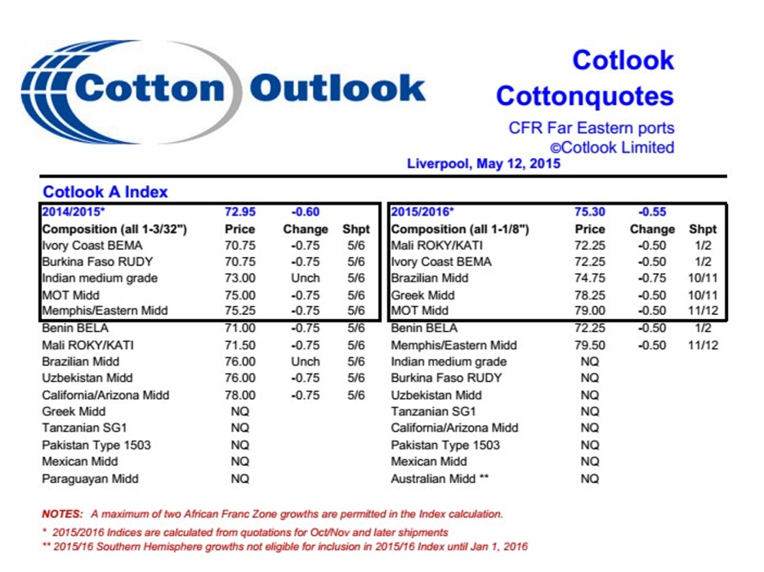
Figure 1. Quotation of cotton fiber by the global stock exchange
http://www.cotlook.com/

1-3/32 (type 5) and 1-1/8 inch (type 4) cotton fibers are priced separately. Currently, 1-1/8" is the most traded since 86% of the world's fiber length is over 1-1/8". At the same time, this information highlights 5 countries with low average fiber prices. The average prices of these 5 countries are calculated as the average fiber prices for the world.
Freight is a contractual or statutory payment for the carriage of goods paid by the shipper or charterer to the carrier. Carriage of cargo on a chartered vessel, as well as a contract of carriage containing the description of the cargo, the carrier's obligations and the amount of the fee, can also be cargo. The amount (rate) of the cargo is determined by the agreement of the parties, if there is no agreement, then the amount (rate) of the cargo is calculated based on the tariffs applied at the place of loading and at the time of loading. If more cargo is loaded on the ship, the cargo amount (rate) will increase. With the development of cargo transportation in various types of transport, the concept of cargo is also applied to air freight and land freight.
Freight (German: Fracht) - payment to the owner of vehicles (mainly sea) for services provided to them in the transportation of passengers or cargo, as well as - depending on the terms of the contract - payment for loading, unloading and collection . Most often, a charterer works as a payer, that is, a person who has concluded a transportation contract with the owner of the vehicle (carrier). Usually, Freight is paid after the shipment is completed.
The geographic base of the A index has been calculated with Far East quotations since 2003. The shift in the geographic base of the A index from the long-established Northern European index is a logical sequence that reflects important movements in the geography of world cotton trade.
Index A and A (Northern European) index base index is "First" grade, fiber quality corresponding to the middle class, i.e. Middling 1-1/8" (36 codes). This, in turn, makes it possible to determine the average prices of a wide range of raw material offers on the world market. Offerings of high-quality raw materials only meet the needs of certain consumers and constitute a very small market sector.
The Kotluk A Index has reflected many changes in the global market during its recent years of activity: from the geographical base of CIF Liverpool to CIF Northern Europe, the quality indicator from SM 1-1/16 to Middling 1-1/8 at base intervals of up to inches. Cotton Outlook is an important transitional period that reflects current changes in the current situation in the world market, and the main goal is to maintain the unrivaled position of the A index as a leading barometer of global cotton price changes.
Cotton A Index Quality Parameters Basis Index Middling 1-1/8" by calculating the arithmetic mean of the five cheapest quotations from the Far East Quotation List for a given day, including cotton In previous cotton seasons, the components of the A index included 19 quotations:
Memphis/East | Uzbekistan | Greece
California/Arizona | Paraguay | Australia
Orlean/Texas | Pakistan 1503 | Mexico
Tanzania (Tip 1SG) | The shores of Slonoy Kosti (BEMA) | Syria
Southeast Turkey (STD 1RG) | Burkina Faso (RUDY) | Brazil
India (H-4/MECH-1/BUNNY) | Benin (BELA) | China 328
 | Mali (KATY)
For the calculation of the A index, no more than two quotes from countries in the African franc area are allowed to be included among the five cheapest offers on any given day.
Kotluk A (SE) index - this index is defined for cotton fiber with a medium quality indicator (Middling 1-1/8) and is the five cheapest quotations from the Northern European list for a given day. is obtained by calculating the arithmetic mean value. In the previous cotton season, 15 components were included in the A (CE) Index group:
Memphis/East | Uzbekistan | Greece
California/Arizona | Paraguay | Australia
Tanzania (Tip 1SG) | Pakistan 1503 | Syria
South-Eastern Turkey (STD 1RG) | Africa (Frank Territory) | Brazil
India (H-4/MECH-1) | Spain | China 328
Kotluk B (SE) index - this index group includes raw materials intended for the production of kalava yarns, which are mainly of low quality according to quality indicators. The B (SE) index is calculated by the simple arithmetic average of the three cheapest quotes from the nine lists of this group:
Orlean/Texas SLM 1-1/32” | Uzbekistan
Argentina GradeC-1/2 | China Type 527
Brazil SLM1-1/16” | Pokistan AFZAL 1-1/32
Southeast Turkey STD2 RG 1-1/16 | India J-34
Syria SLM 1-1/16
Sometimes raw materials from a certain region are included or excluded from the list. Advance notice will be posted on all services.
Binary Index System From an arithmetical point of view, the way indices are calculated has not changed since they were first introduced. However, starting in 1988, the traditional practice of replacing old crop prices with new product offers was changed by the introduction of the Binary Index System.
According to the two-index sequence system, two series of the same index (one for the current season and the other for the next season) are traded simultaneously in the market from the moment of the appearance of forward offers from the previous cotton season to the last trading day. will be published in After that, the forward offers and the Index are introduced, and the new season's forward offers are published separately before entering the market (usually at the beginning of the calendar year). Advance quotations should reflect product shipments beginning before October-November of the upcoming new season. The exact date for the announcement of the forward indices is not fixed and depends on the prevailing market conditions.
Previously, forward indices were sometimes introduced from February, and forward B indices were introduced almost as late as July. October-November are considered the months of the first shipment (rather than August-September), because it is in these months that large quantities of cotton fiber begin to be shipped from the countries of the Northern Hemisphere to the world market. Crude deliveries from the Southern Hemisphere until January are not taken into account in the calculation of indices, even if these quotes are included in the group list.
One of the advantages of Index A is that for many years it has been used as a barometer that determines the average price of fiber in the world cotton market.
The United Nations Committee on Trade and Development (UNCTAD) uses the A Index as an integral part of measuring agricultural price levels. Since the 1970s, the International Cotton Advisory Committee (ICAC) has used the A-index as its preferred price measure and, through this body, as a tool to control world market prices. The ICAC Committee has developed a price forecasting model that attempts to predict the average seasonal level of the Kotluk A Index for ICAC member countries. Since then, the US Department of Agriculture has started using the Kotluk A index as one of the criteria for setting a "target price" (the price US farmers hope to receive for cotton). Since 1985, the Kotluk A index has been a key component of the US Trade and Credit Corporation's "marketing credit" (US farmers borrow money from the government and pay back less if the Kotluk A index is lower than the credit level).
Ministries and agencies that regulate trade in the Republic of Uzbekistan and similar state bodies of other Central Asian republics use index A or the average index of index A and its component in Uzbekistan in their export price policy, from the Kotluk A index. used. The Kotluk A index is an integral part of the price support system for cotton farmers in the EU countries.
Currently, according to the information of the International Cotton Advisory Committee (ICAC), the production of cotton fibers in the world is 24.27 million tons, and the consumption is 23 million tons.
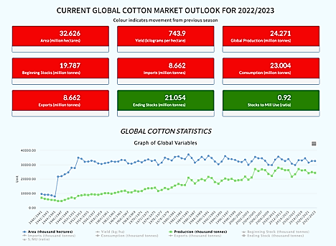
The average current price forecast for the 2022/23 cotton A index rose from 97.9 cents to 151.5 cents, with an average price of 115 cents per pound. The global forecast for the world cotton market indicates that fiber production will remain high enough to meet consumption, especially as consumption continues to decline.
Even if cotton production had not been affected by these disasters, uncertainty about the strength of the global economy has prompted investors to expect a decline in consumption. Falling production usually leads to higher prices, but when combined with macroeconomic concerns, one can expect volatility that is difficult to predict. But in West Africa, cotton production has revived. If the projected numbers are realized, the region will achieve the highest production.
According to the end of the 2021/22 cotton season around the world:
- cotton cultivated area decreased by 1% to 32.78 million hectares;
- production of 26.13 million tons;
- consumption was 26.09 million tons.
To assess the impact of these indicators on prices, the stock utilization ratio, which measures the available cotton stocks as a percentage of cotton mill utilization, helps determine the relationship between cotton supply and demand. If the supply is higher than the demand, the ratio will be lower. A low stock utilization ratio may indicate high prices. On the contrary, when the supply exceeds the demand, this ratio increases and affects the decrease in the price of cotton. Planted area can also have a big impact on prices, as shown in the graph below:
In other words, demand remained high all year - the challenge was actually getting the fiber from one sector of the supply system to another and ultimately to consumers. While strong U.S. export performance is a sign that problems are easing, delays through the complex shipping and transportation system will take time to clear, and full normalization may take longer. .
While cotton production declined by 22% in most cotton-growing countries, cotton acreage in West African countries increased by 44% in 2021/22. This impressive growth was due to the recovery of cultivated areas in Mali
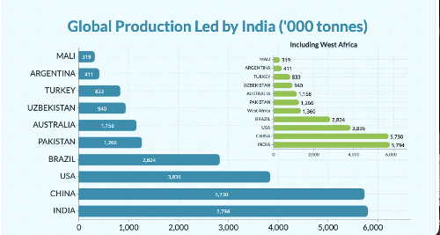
Average A-index prices for the 2021/22 cotton season averaged 115 cents per pound.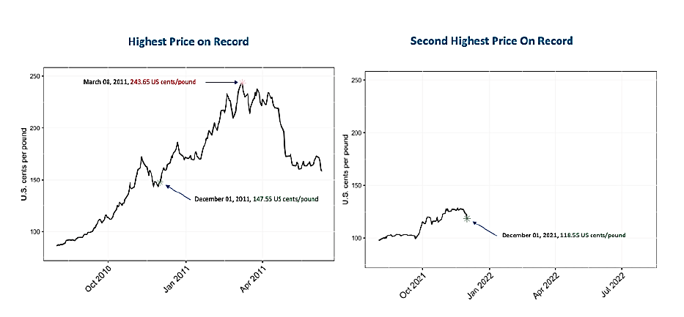
While utilization of cotton gins is expected to remain robust through the 2021/22 cotton season, global stocks have been observed to be sufficient to meet demand. At the end of the 2020/21 season, the amount of reserves in the world is 20.35 million tons.
During the last cotton harvest, cotton production increased by 6% and amounted to 25.7 million tons, which is lower than the period before the previous pandemic. Australia, Brazil, and the United States were able to compensate for expected declines in the world's two largest producers, China and India, thanks to increased production.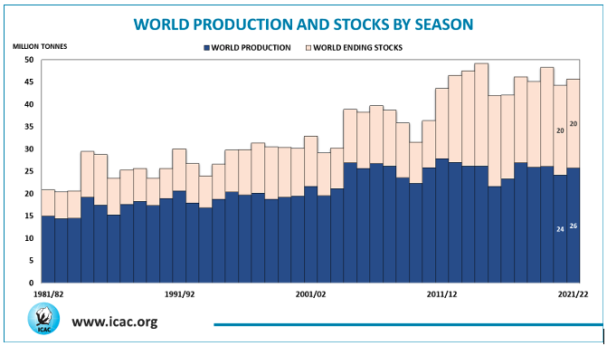
The expected disparity in the supply and demand for cotton in the world and the tightening of final stocks prevent the price of cotton fiber from being stable. Currently, cotton prices fluctuate, and the Kotluk A index averages 105 cents per pound.
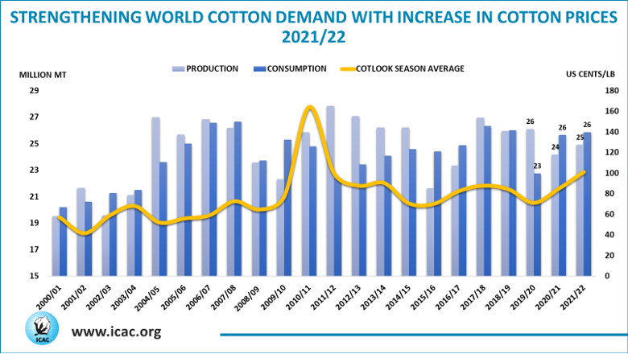
Ending stocks are expected to decline for the second year in a row as demand outstrips production. In 2021/22, the final reserves are 19.7 million tons, which is 5% less than the previous season.
Growth in global cotton production is expected to reach 3.8 million tons in the U.S., up 22 percent from the previous season.
In the 2020/21 season, positive growth was achieved in global cotton consumption and trade. Consumption increased by 12.4% to 25.5 million tons.
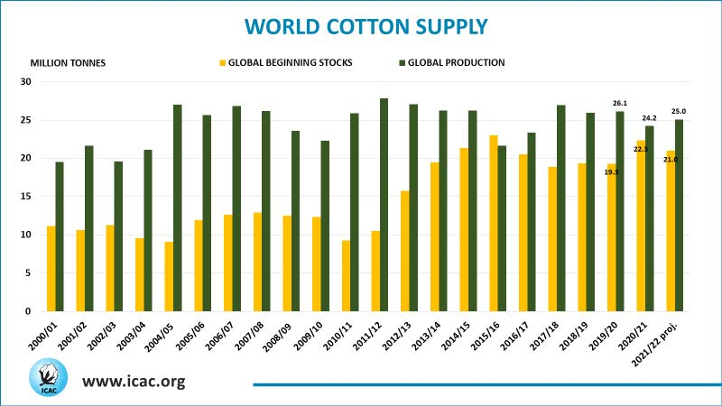
http://icac.com/
About fiber price differentiation
In Uzbekistan, fiber price differentiation was adopted in 1995, and today this differentiation price and additional premiums and discounts are traded through commodity exchanges on the basis of world market prices. Currently, Uzbekistan is in the seventh place in the production of cotton fiber, and on average, it produces about 1 million tons of fiber. As a result of the increase in the number of cotton fiber consumers in our republic, cotton fiber export was not carried out in 2022.
In Uzbekistan, the "First" grade, the "Middle" grade, and 4 types are defined as the basis for determining the average prices of cotton fiber. If, in order to determine the average price of Uzbek cotton according to Index A (Middling, 1-1/8), the index quotation (s/f) of this day is taken, and it is accordingly multiplied by the constant coefficient of 22.046 for calculations. distributed, and the determined number determines the price ($/tn) of "First" grade, "Middle" grade, type 4 cotton fiber on this day. For example, on December 22, 2022, the average price of the A index quote on the Liverpool Stock Exchange was set at 105.55 s/f. In this case, 105.55 was in US currency, that is, 1 dollar was 5.55 cents. This price is calculated as the price of one pound of fiber (1 pound is 460 grams on average). 105.55 x 22.046 = $2327/ton. So, the price of 1 ton of "First" grade, "Middle" class, 4 types of cotton fiber on the specified day is 2327 US dollars.
Table 1
Grade/  class | Oliy | Yaxshi | О‘rta | Oddiy | Iflos
I | 2,0  +5,0 | 2,5  +4,0 | 3,0  bazis | 4,0  -3,5 | 5,5  -7,5
II | 2,5  +2,0 | 3,5  -1,0 | 4,5  -4,5 | 5,5  -8,0 | 7,0  -12,0
III | 3.0  -1,0 | 4,0  -3,5 | 5,5  -7,0 | 7,5  -11,0 | 10,0  -16,0
IV | 4,5  -5,0 | 6,0  -15,0 | 8,5  -20,0 | 10,5  -25,0 | 14,0  -30,0
V | 6,5  -25,0 | 8,5  -35,0 | 10,5  -45,0 | 12,5  -50,0 | 16,0  -55,0

The price differentiation for 5 varieties and classes according to the
UzDSt 604 standard is presented in percentages in Table 8.1 below.
As a result of studying the quality, quantity and price of fiber in the world market, it is observed that there are still some shortcomings in the price differentiation of Uzbek cotton today. Including:
- A discount of 3.5 percent is set for the "Third-Good" indicator and the "First-Normal" indicator. This, in turn, makes it difficult for customers to purchase fibers rated as "Third-Good". The reason is that it is much more profitable to buy 1st grade fiber with a 3.5 percent discount;
- Uzbek cotton price discounts for low grades are very high, i.e. up to 30% for the 4th grade, and up to 55% for the 5th grade compared to the base "First-Medium";
- Intermediate discounts for 4-5 varieties are very high and amount to 25 percent;
- The discount between grades 4-5 is set at 5%, while this indicator is set at 1-4% for grades 1-3.

Review questions:
1. Where does Index A come from and how is the price distributed by fiber?
2. Which quality indicator is called the base
3. In what year was the last change to the standard, how did the price differentiation by classes change?
4. What is Index B?
5. List the main quality indicators that affect the price of fiber

Main conclusions:
1. Middling, 1-1/8 is adopted as the main basic quality indicator of cotton fiber in A index.
2. In index B, SLM is 1-1/16 according to the quality indicator of cotton fiber, and it is set one class lower than index A and one code in terms of fiber length.
3. Freight is a payment for the carriage of goods required by contract or law, paid by the shipper or charterer to the carrier.
4. worldwide production of cotton fiber is 24.27 million tons, and consumption is 23 million tons.
5. "First" grade, "Middle" grade, 4 types are defined as the basis for determining the average prices of cotton fiber in Uzbekistan.
6. In Uzbekistan, fiber price differentiation was adopted in 1995
7. Kotluk B (SE) index - this index group includes raw materials intended for the production of kalava yarns, which are mainly of low quality according to quality indicators

Tests on the topic of cotton fiber marketing in the world market:
1. What do you mean by quality?
a) Quality regardless of the buyer's social status, that is, whether he is a businessman, a housewife, an engineer, etc. it is suitable to fully satisfy its demand
b) Quality - the seller likes the product, the attractiveness of the product's appearance and its low cost.
c) Quality - a characteristic of the product, the appearance of the product, its operation without damage, ease of repair
d) Quality - a characteristic that shows that the buyer can determine the suitability of the product in all respects, and that it is suitable for satisfying the needs.
2. What are the stages of quality assurance?
a) Stages of quality development
b) Quality system, including its assessment and quality control
c) Existing stages in determining quality
d) Ways to improve product quality
3. How many types of cotton fiber are there?
a) There are 9 types
b) There are 8 types
c) There are 10 types
d) There are 11 types
4. How many grades and industrial varieties of cotton fiber are there?
a) Class 6, industrial type III
b) 5 class V industrial variety
c) Class 3, industrial type V
d) 6th class, IV industrial type
5. What is the indicator of thickness or thinness of cotton fiber called?
a) The degree of fineness of the fiber
b) Micronaire
c) Linear density
d) Relative tensile strength
6. The classes of cotton fiber are shown correctly in which answer?
a) good, medium, dirty, very dirty
b) High, good, medium, dirty, very dirty
c) High, good, medium, normal, dirty
d) High, normal, good, dirty, medium
7. In which laboratory equipment is the microneural index of the fiber determined?
a) HVI 1000
b) LPS-4
c) DSh-3M
d) In the stellometer
8. Which answer fully describes the methods of determining the relative tensile strength of a fiber?
a) Stelometer, Zhukov's device
b) HVI system Zhukov device
c) Press dynamometer, stellometer, HVI system
d) Dynamometer
9. Which equipment determines the high average length of the fiber?
a) In a micrometer instrument
b) Classer method
c) HVI in the laboratory system
d) In Zhukov's device
10. What types of cotton wool are divided according to the length of the staple?
a) Type A, Type B
b) Type A, Type V, Type C
c) 3 different types
d) 4 different types

Informational and methodological support:
1. M. Khodjiyev, A. Salimov "Determination of fiber quality". "Turon-Iqbal". T., 2006.
2. R. Boriyev, Q. Jumaniyazov, A. Salimov "Determining the quality of cotton". T.:, "Cotton Industry Scientific Center" JSC - 2016.
3. А.Salimov, Wang Hua, T.Tuychiyev «Technology and equipment for primari cotton processing» China, 2019 – p. 174.
4. S.Gordon and Y.L.Hsieh. Cotton: Science and technology The textile institute. Wood Head Publishing Limited. Cambridge, England 2007
5. www.cotlook.com

