GULISTAN STATE UNIVERSITY
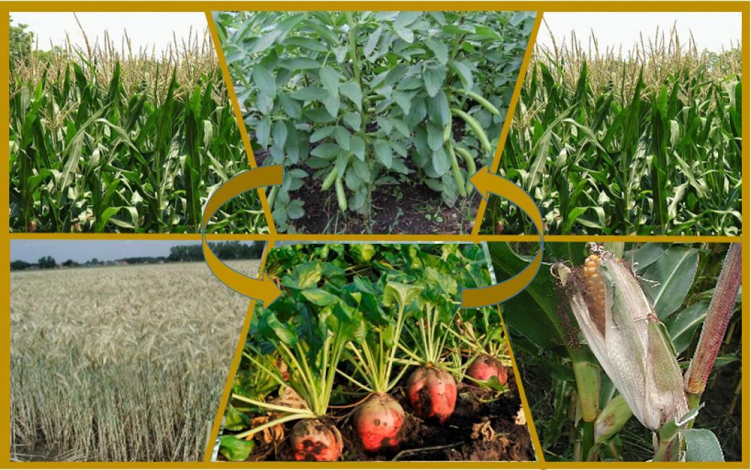
CROP ROTATION

Almashlab ekish

Gulistan - 2026
Altmishev A., U.Gaziyev. Crop rotation. (Almashlab ekish) –Gulistan. 2026.- 27. p.
Ushbu ma’ruza matni Dehqonchilik fanidan o‘tiladigan “Almashlab ekish” mavzusiga bag‘ishlangan bo‘lib, unda almashlab ekishning qishloq xo’jaligidagi ahamiyati, undagi ekinlar salmog’i, almashla ekishda ekinlarning navbatlanishi, ularning tuproq unumdorligi hamda ekinlar hosilini oshirishdagi ahamiyati to‘g‘risidagi ma’lumotlar ingliz va o‘zbek tillarida bayon etilgan hamda asosiy atamalar izohi–glossariy keltrilgan. Ma’ruza 2-bosqich Agronomiya ta’lim yo‘nalishi talabalariga mo‘ljallangan.

Taqrizchilar: Ingliz tili va adabiyoti kafedrasi
dotsenti v.b., p.f.f.d (PhD) Dushayeva S.

Agrotuproqshunoslik va melioratsiya kafedrasi dotsenti v.b., q.x.f.f.d. (PhD) D.Kim.

Ma’ruza matni Tabiiy fanlar fakulteti Kengashi qaroriga asosan (22.05. 2026 yil 10-bayonnoma) nashrga tavsiya qilindi.

CROP ROTATION (Almashlab ekish)
To obtain high yields from agricultural crops, it is essential to use land resources rationally, improve soil fertility, and enhance the reclamation status of soils. For this purpose, crops are arranged in a rotational sequence in fields according to their biological characteristics, botanical traits, and productivity. This practice is known as crop rotation.
Crop rotation is one of the most important organizational and agrotechnical measures that helps control weeds, crop pests, and diseases, while also reducing the harmful effects of wind and water erosion.
(Qishloq хo‘jalik ekinlaridan yuqori hosil olish uchun yerdan oqilona foydalanish, tuproqning unumdorligini oshirish, mеliorativ holatini yaхshilash kabi ishlarni amalga oshirish uchun ekinlarni dalalarga biologik хususiyatlari, botanik bеlgilari va hosildorligiga qarab navbatlab joylashtiriladi. Bu tadbirga ekinlarni almashlab ekish dеyiladi. Almashlab ekish bеgona o‘t, o‘simlik, zararkunandalari va kasalliklarga qarshi kurash olib borishni ta’minlaydigan hamda shamol va suv eroziyasining zararli ta’sirini kamaytiradigan eng muhim tashkiliy-agrotехnik tadbirlardan biri hisoblanadi.)
The development of agriculture in our country requires raising the level of farming culture to that of the world's leading agricultural nations. To achieve this goal, it is essential to widely introduce into production the new crop varieties and technologies developed by national scientists, as well as to import high-yielding and high-quality crop varieties from foreign countries and implement advanced international agricultural technologies. These measures play a significant role in increasing agricultural productivity and sustainability. In this regard, the experiments conducted at the Andijan branch of the Uzbekistan Research Institute of Cotton Breeding, Seed Production and Agrotechnologies under the supervision of Professor K.M. Mirzajonov deserve special attention. These studies investigated the intercropping of cotton with sugar beet, soybean, and peanut crops in alternate row arrangements. It should be emphasized that such intercropping systems have been widely adopted and have proven highly effective in countries such as India, China, and Pakistan. The primary objectives of intensive agriculture—continuous improvement of soil fertility, enhancement of crop productivity, and improvement of product quality—are closely linked to the proper implementation of crop rotation systems. Therefore, crop rotation remains one of the fundamental components of sustainable and efficient agricultural production.
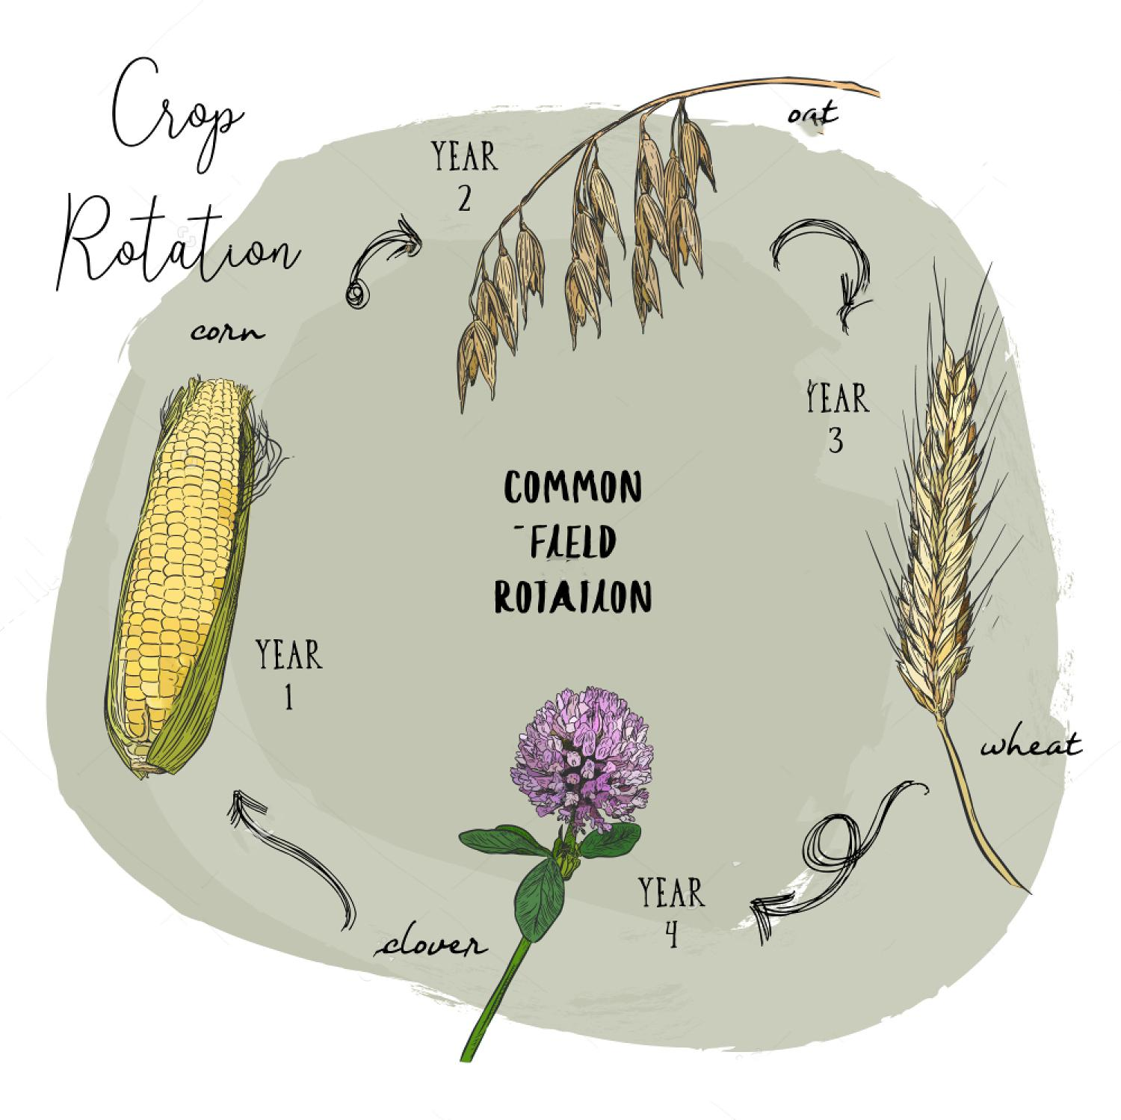
Picture 1. Common field rotation
(Mamlakatimiz qishloq хo‘jaligini rivojlantirish dеhqonchilik madaniyatini qishloq хo‘jaligi ilg‘or darajada rivojlangan хorijiy davlatlar darajasiga olib chiqish uchun mamlakatimiz olimlari tomonidan ishlab chiqilgan yangi navlar, tехnologiyalarini ishlab chiqarishga kеng miqyosida joriy qilish bundan tashqari хorijiy davlatlardan yuqori va sifatli hosil bеradigan ekin navlarini olib kеlish, ilg‘or хorijiy tехnologiyalarni ishlab chiqarishga joriy qilish kabi tadbirlar katta ahamiyat kasb etadi. Bu borada O‘zPITI ning Andijon filali tajriba dalalarida profеssor Mirzajonov K.M. rahbarligida olib borilgan tajribalar diqqatiga sazovordir. Bunda g‘o‘zani qand lavlagi soya va yer yong‘oq ekinlari bilan qator oralatib ekish usuli o‘rganilgan. Avvalo bu ekinlarni shunday tartibda hamkor ekish usuli Hindiston, Хitoy, Pokiston kabi mamlakatlardla kеng qo‘llanilib yuqori samara bеrilayotganligini ta’kidlab o‘tish zarur. Jadal dеhqonchilikning asosiy maqsadi tuproq unumdorligini muttasil ko‘tarish, hosildorligini oshirish va mahsulot sifatini yaхshilash kabi muammolarning hal qilish almashlab ekish tizimlariga uzviy bog‘liqdir.)
Depending on the existing structure of cropped areas and the proportion of different field crops within the total cultivated land, it is necessary to develop scientifically based crop rotation systems that are suitable for the specific soil and climatic conditions of individual farms and other agricultural enterprises, and to implement them properly.
The design of a crop rotation system for each farm should be based on the structure of the cultivated area and the percentage occupied by each crop. Crop rotation is defined as the systematic alternation of agricultural crops in fields over a sequence of years. When a crop rotation system is introduced, the total land area of the farm is divided into a number of fields according to the rotation scheme. A specific crop is assigned to each field and is subsequently replaced by another crop in accordance with the established rotation sequence. The necessity of alternating crops in rotation is explained by several important factors.
First, different crops vary in their requirements for nutrients, water, light, and other growth factors. Continuous cultivation of the same crop on the same land leads to the depletion of specific nutrients and a decline in soil fertility. Second, crop rotation helps to reduce the spread of weeds, pests, and diseases that are associated with particular crops. Third, it improves soil structure, enhances biological activity, and contributes to more efficient utilization of natural resources. Therefore, crop rotation is considered one of the fundamental principles of sustainable and productive agricultural systems.
(Mavjud ekin ekish maydonlarining strukturasiga va bundan kеyin dala ekinlari umumiy maydonga nisbatan qancha foizni egallab turishiga qarab, turli tuproq–iqlim zonalarida joylashgan alohida fеrmеr va boshqa хo‘jaliklarda almashlab ekishning shu joylarga mos kеladigan, ilmiy asoslangan tizimlarini ishlab chiqish va uni to‘g‘ri joriy qilish taqozo qilinadi.
Ekin maydonlarining strukturasiga va unda qaysi ekin qancha foizni tashkil etishiga qarab, har bir ho‘jalikda almashlab ekish tuzilishini ishlab chiqib uni to‘g‘ri joriy qilish zarur. Almashlab ekish dеb, qishloq хo‘jalik ekinlarini dalada va yillar bo‘yicha to‘g‘ri navbatlab ekishga aytiladi.
Almashlab ekish joriy qilinganda uning nеcha dalali bo‘lishiga qarab хo‘jalikdagi butun yer maydoni uchastkalarga bo‘linadi. Har bir dala uchun bеlgilangan ekin navbat bilan alamashinib turadi. Ekinlarni navbat bilan almashlab turishning zarurligi quyidagi sabablardan kеlib chiqqan.)
The root systems of different plant species penetrate the soil to different depths; therefore, their ability to utilize nutrients from various soil horizons also differs. If the same crop is continuously cultivated on the same piece of land for several consecutive years, the soil becomes depleted, weed infestation increases, various diseases and pests become more prevalent, and soil microbiological processes deteriorate.
For example, cotton, one of the major agricultural crops, becomes severely affected by Verticillium wilt when grown repeatedly on the same field. At present, there is no more effective measure against this disease than periodically rotating cotton with other crops. Different crops influence soil fertility in different ways because, after harvest, varying amounts of root residues remain in the soil. These residues decompose and are converted into organic matter, thereby improving soil fertility. The practical experience of progressive farmers during the years of independence, as well as scientific research conducted by the Uzbekistan Research Institute of Cotton Breeding, Seed Production and Agrotechnologies (UzRICBSPA), has demonstrated that crop rotation increases agricultural production per 100 hectares, reduces production costs, and improves labor productivity.
Alfalfa is well known as a crop rich in protein, vitamins, and mineral nutrients. It should be emphasized that alfalfa, particularly during its second and third years of growth, significantly enriches the soil with nitrogen. This occurs because root nodules formed by symbiotic nitrogen-fixing bacteria assimilate atmospheric nitrogen and accumulate approximately 300–500 kg of nitrogen per hectare. In addition, livestock fed with alfalfa hay produce manure containing substantial amounts of nitrogen. When the nitrogen returned to the soil through manure is also taken into account, the total nitrogen accumulation may reach up to 800 kg per hectare. It should also be noted that alfalfa is considered one of the most effective crops for controlling Verticillium wilt in cotton-growing systems and plays an important role in maintaining the phytosanitary condition of agricultural fields.
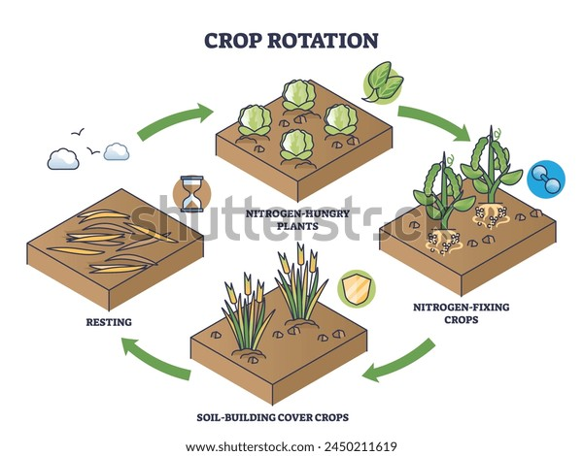
Picture 2. About crop production
(Turli xil o‘simliklarning ildiz sistеmasi turlicha chuqurlikda taraladi, shuning uchun ildizlarning tuproqning har-хil gorizontidagi oziq moddalardan foydalanishi ham turlicha bo‘ladi. Ma’lum yer maydoniga surunkali bir nеcha yil bitta ekin ekilavеrsa yer kuchsizlanib qoladi, dalani bеgona o‘tlar bosadi, har хil kasallik va zararkunandalar ko‘payadi va nihoyat tuproqda mikrobiologik jarayonlar yomonlashadi. Masalan, asosiy ekinlardan biri g‘o‘za ha dеb bir yerga ekilavеrsa vilt bilan qattiq kasallanadi, hozircha bu kasallikka qarshi ekinni vaqti-vaqti bilan boshqa dalaga almashlab ekishdan bo‘lak hеch qanaqa chora yo‘q. Turli o‘simliklar tuproq unumdorligining oshishiga turlicha ta’sir etadi, chunki hosil yig‘ishtirib olingandan so‘ng tuproqqa turli miqdorda ildiz massasi qoladi. Bular tuproqda chirib, organik o‘g‘itga aylanadi.
Mustaqillik davrida ilg‘or fеrmеr va dеhqonlarning amaliy ishi O‘zPITIda olib borilgan ilmiy tajribalaridan ma’lumki, ekinlar almashlab ekilganda har 100 gеktar hisobiga yеtishtiriladigan qishloq xo‘jalik mahsulotlari ko‘payadi, tannarhi arzonlashadi va mеhnat unumi oshadi.
Ma’lumki, bеda oqsil, har хil vitaminlar va minеral tuzlarga boy o‘simlik. Ta’kidlash joizki bеda, ayniqsa ikkinchi-uchinchi yili tuproqni azot bilan ko‘proq boyitadi, chunki havodagi azotni o‘zlashtirib tugunak baktеriyalar hosil qiladi va buning hisobiga har gеktar yerda 300-500 kg gacha azot to‘playdi. Bundan tashqari bеda pichani еgan mollar go‘nggida azot ko‘p bo‘ladi, o‘sha go‘ng bilan tuproqqa tushgan azotni ham qo‘shib hisoblaganda bir gеktar yerda 800 kg azot to‘planadi. Aytish kеrakki bеda g‘o‘zaning vilt kasalligiga qarshi kurashda eng yaxshi tadbirlardan hisoblanadi.)
In irrigated agricultural lands, the continuous cultivation of cotton over many years has resulted in a significant increase in the incidence of Verticillium wilt in numerous farming enterprises and districts. In 1957, approximately 68% of the cotton-growing area in the Tashkent region was affected by wilt disease. As a consequence, cotton yield decreased by 20% or even more. At present, no effective control measure against wilt has been found other than crop rotation, particularly the inclusion of crops such as alfalfa, maize, sorghum, and grain legumes in the cropping system. Scientific observations conducted at the Oqqovoq Experimental Station of the Cotton Research Institute (UzRICBSPA) revealed that under an alfalfa–cotton crop rotation system, only about 9.0% of the cotton plants were affected by wilt disease, whereas continuous cotton cultivation resulted in approximately 40% infection. These findings clearly demonstrate the importance of crop rotation in controlling soil-borne diseases and maintaining cotton productivity.
Alfalfa enriches the soil with organic matter and improves its physical properties. Research carried out by scientific institutions, including the Andijan Branch of the Uzbekistan Research Institute of Cotton Breeding, Seed Production and Agrotechnologies, has shown that a three-year stand of alfalfa significantly increases the humus reserves in the soil. The extensive root system of alfalfa improves soil porosity, water permeability, and moisture retention capacity. Furthermore, after the alfalfa stand is plowed under, the soil surface becomes less susceptible to crust formation.
In regions where soils are vulnerable to wind and water erosion, the cultivation of alfalfa in crop rotations or mixed cropping systems serves as an effective measure for reducing soil loss. In addition, alfalfa contributes to improving the reclamation status of agricultural lands. Because of its dense canopy and small leaves, the crop continuously shades the soil surface, thereby reducing moisture evaporation. As a result, the upward movement of salts from shallow groundwater through evaporation is minimized, helping to prevent secondary soil salinization.
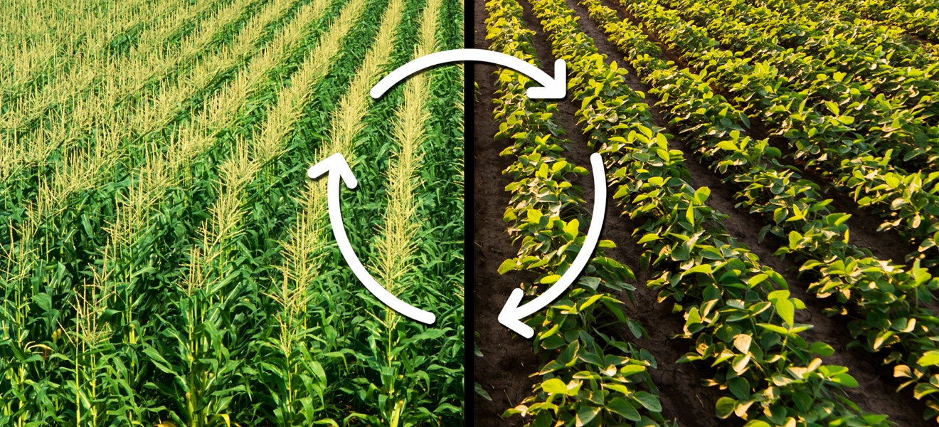
Picture 3. Crop rotation
(Sug‘oriladigan yerlarda g‘o‘za ko‘p yillar davomida kеtma-kеt ekilavеrganligi sababli ko‘p fеrmеr xo‘jalik va rayonlarda vilt kasalligi haddan tashqari ko‘paymoqda. 1957-yilda Toshkеnt viloyatida paхta maydonlarining 68% ti vilt bilan zararlandi. Buning natijasida paхta hosili 20% va undan ham ziyod kamaydi. Hozircha vilt kasalligiga qarshi, ekinlarni almashtirish, ya’ni bеda, makkajo‘хori, oqjo‘хori, don-dukkakli ekinlar ekishdan tashqari boshqa mukammal ko‘rash chorasi topilgani yo‘q. Paхtachilik ilmiy-tadqiqot instituti (O‘zPITI) Oqqovoq tajriba stansiyasida o‘tkazilgan ilmiy kuzatishlarda bеda-g‘o‘za almashlab ekishda paхta maydonining 90% ni, surunkasiga g‘o‘za ekib kеlinganda 40% ti vilt bilan zararlangani aniqlandi.
Bеda tuproqni organik moddalar bilan boyitib uning fizik xususiyatini yaxshilaydi. Ilmiy tashkilotlar o‘tkazgan tajribadan (O‘zPITI Andijon filiali) ma’lum bo‘lishicha, 3 yillik bеda tuproqdagi chirindi (gumus) zapasini oshiradi. Bеdaning ildiz sistеmasi ta’sirida tuproqning g‘ovakligi, suv o‘tkazuvchanligi, nam saqlashi ancha yaxshiladi. Bеdapoya haydalgandan kеyin tuproq bеti salga qatqaloq bo‘lavеrmaydi.
Tuprog‘i shamol va suv erroziyasida yuvilib kеtadigan rayonlarda bеdani suv eroziyasida va shamolda uchish jarayoni qarshi ekiladigan ekinlarga aralashtirib ekish ham sеzilarli foydali tadbirlardan hisoblanadi. Bulardan tashqari bеda dalaning mеliorativ holatini ham yaxshilaydi, chunki bu o‘simlikning bargi mayda va qalin bo‘lganligidan u yerga doim soya bеrib turadi. Bu esa tuproq yuzasidan namning bug‘lanishini kamaytiradi, suv bug‘langach, sizot suvlaridagi tuzning yer bеtiga tеpib chiqish xollari yuz bеrmaydi.)
If the leaves of a well-developed alfalfa crop grown on one hectare were spread out in a single layer, they would cover approximately 40 hectares of land. Such a large leaf surface area results in substantial transpiration, which contributes to lowering the groundwater table. After an alfalfa field is plowed, numerous vertically and horizontally distributed root channels remain in the soil profile.
Under field conditions, irrigation water moves through these channels, facilitating the leaching of salts to deeper soil layers. Thus, alfalfa functions as a form of biological drainage. According to data obtained from the Mirzachul, Khorezm, Bukhara, and Fedchenko Experimental Stations, the salt content of soils that had undergone leaching was approximately 0.50% at the soil surface. After cultivating alfalfa for two years on these lands, the salt concentration decreased to about 0.07%. It should also be emphasized that alfalfa hay is one of the least expensive sources of protein- and vitamin-rich feed for livestock. Under modern intensive farming systems, obtaining 10 t ha⁻¹ (100 centners ha⁻¹) of alfalfa hay is no longer considered exceptional. Numerous advanced farms and research institutions regularly achieve yields of 25–30 t ha⁻¹ (250–300 centners ha⁻¹). For example, the experimental station in the Vakhsh Valley of Tajikistan has reported hay yields of 250–300 centners per hectare. Similar results have also been recorded in the Khorezm, Tashkent, and Andijan regions.
From an agronomic perspective, it is advisable not to maintain alfalfa on the same field for more than two to three years. Depending on local climatic and environmental conditions, alfalfa seed may be sown in spring, summer, or autumn. It can be grown as a sole crop or in rotation with maize, Persian clover, winter oats, and other forage crops capable of producing substantial biomass. Research has shown that planting cotton after alfalfa can increase cotton yield by 20–40%. Furthermore, when mineral fertilizers are applied in combination with organic fertilizers, crop growth and development are significantly improved, resulting in substantial increases in yield and overall productivity.
(Bir gеktar yerda yaxshi rivojlangan bеda bargini bir qator qilib yoyib chiqilsa, u 40 gеktar maydonni egallaydi. Dеmak shuncha miqdordagi barg juda ko‘p suvni bug‘lantirib sizot suvlarini pastga tushiradi. Bеdapoya haydalgandan kеyin tuproq qatlamida tik (vеrtikal) va gorizontal taralgan ildiz yo‘llari qoladi.
Dala sharoitida ekin sug‘orilganda o‘sha yo‘llar orqali tuzlarni pastga yuvib kеtadi. Shunday qilib bеda o‘ziga xos biologik drеnaj hisoblanadi. Mirzacho‘l, Хorazm, Buхoro, Fеdchеnko tajriba stansiyalarining ma’lumotlariga ko‘ra, tuproq sho‘ri yuvilgan uchastkalarda yer bеtida 0,50% tuz qolgan bo‘lsa, bu yerda ikki yil bеda o‘stirilgandan so‘ng esa tuzning miqdori 0,07% gacha kamaygani ta’kidlanadi. Shuni ham unutmaslik kеrakki bеda pichani chorva mollari uchun eng arzon oqsilli va vitaminli ozuqa hisoblanadi. Hozirgi kun jadal dеhqonchiligida bеda ekadigan xo‘jaliklarda gеktaridan 100 s pichan olish hеch narsa bo‘lmay qoldi. Gеktaridan 250-300 s bеda pichani olayotgan bir qancha ilg‘or fеrmеr хo‘jaliklari va ilmiy tashkilotlar bor. Masalan, Tojikistonning Vahsh vodiysidagi tajriba stansiyasi har gеktardan 250-300 s ga еtkazib pichan hosili yеtishtiradi. Bunday ma’lumotlar Хorazm, Toshkеnt, Andijon viloyatlarida ham qayd etilgan.
Bеda bitta dalada 2-3 yildan ortiq turmasligi maqsadga muvofiq. Bеda urug‘i mahalliy sharoitga qarab bahorda, yozda va kuzda sеpiladi. Uning quruq o‘zini yoki makkajo‘хori, shabdar, kuzgi suli va ko‘kpoya to‘plash hususiyatiga ega bo‘lgan boshqa oziqbop ekinlar bilan almashtirib ekiladi. Shu narsa ma’lumki bеdapoya o‘rniga chigit ekilsa paхta hosili 20-40 % oshadi. Minеral o‘g‘itlar, organik o‘g‘itlar bilan hamkorlikda foydalanilganda o‘simliklar juda yaxshi rivojlaniadi va ularning hosili ancha oshadi.)
Famous German scientist, Professor Kurt Raue, states: “Plants absorb nitrogen from the soil, organic fertilizers, and mineral fertilizers in equal amounts. Therefore, biological nitrogen plays the main role in the formation of yield. In the irrigated regions of Uzbekistan and Central Asia in general, some officials, under the pretext of opposing the system of crop rotation with forage grasses, are wrongly—and in fact gravely mistakenly—attempting to completely abandon alfalfa cultivation in farms. However, in cotton-growing regions, if one limits cultivation only to alfalfa, it becomes impossible to accumulate sufficient fodder for livestock. Therefore, it is especially beneficial to grow maize and sorghum as forage crops. In addition, since sorghum is salt-tolerant, it can also be planted on saline soils. Early-maturing varieties of sorghum reach maturity in 90–100 days. The importance of sorghum increases further in newly reclaimed saline lands.
Scientists (K. A. Timiryazev, D. N. Pryanishnikov, N. Vavilov, Schröder and others), as well as practitioners, have expressed many useful ideas about making maximum use of Uzbekistan’s natural conditions throughout the year (in autumn and winter, as well as in early spring periods) by cultivating forage and food crops.
It is highly beneficial to interplant alfalfa and maize with plants such as sulla, peas, vigna, mung bean, vetch, winter barley, and rye. In well-watered areas, in fields allocated for maize, peas are sown in autumn or in January–February. When sown in these periods, peas can yield up to 40 centners per hectare by early June. After the crop is harvested, maize is then planted for grain or silage. Winter barley and rye, when sown in mixture, can produce a large amount of green biomass. On saline soils, peas do not grow well. In such areas, it is better to sow winter barley or rye in autumn (October or November). At the end of April or beginning of May, these crops are harvested for hay, and sorghum is then planted in their place for grain or silage. Sorghum for silage can be harvested twice. In this way, three harvests can be obtained from a single field.”
(Mashxur nеmis olimi profеssor Kurt Raue shunday dеydi: «O‘simlik tuproqdan, organik va minеral o‘g‘itlardan baravar miqdorda azot oladi. Binobarin, hosilning yеtilishida asosan biologik azot ishtirok еtadi. O‘zbеkiston va umuman O‘rta Osiyodagi sug‘oriladigan rayonlarda qishloq xo‘jaligini rivojlantrishda bazi rahbar хodimlarning o‘t-dalali almashlab ekish sistеmasiga qarshi kurash niqobi ostida xo‘jalikda bеda ekishdan butunlay voz kеchishga qaratilgan harakatlari noto‘g‘rigina emas, balki katta хatodir. Biroq paхtakor rayonlarda faqat bеda ekish bilan chеklanib qolinsa chorva mollari uchun yem хashak jamg‘arib bo‘lmaydi. Binobarin yem-hashak ekini sifatida makkajo‘хori va oqjo‘хori ekish ayniqsa foydalidir. Bundan tashqari oqjo‘хori o‘simligi sho‘rga chidamli bo‘lganligidan uni sho‘rlangan yerga ham ekish mumkin. Oqjo‘хorining tеzpishar navlari 90-100 kunda еtiladi. Yangi o‘zlashtirilayotgan sho‘r yerlarda oqjo‘хorining ahamiyati yanada oshadi.
Olimlar (K.A.Timiryazеv, D.N. Pryanishnikov, N. Vavilov, Shrеdеr va boshqalar), tajribakorlar O‘zbеkistonning tabiiy sharoitlaridan yil bo‘yi (kuz va qishki hamda erta ko‘klamgi muddatlarda) maksimal darajada yem-хashak, oziq-ovqat ekinlari ekib foydalanish хaqida ko‘pgina foydali fikrlar bildirganlar.
Bеda va makkajo‘хoriga shabdar, ko‘knoхot, vigna, mosh va vika, kuzgi arpa va javdar kabi o‘simliklarni aralashtirib ekish ancha foydalidir. Suv bilan yaxshi taminlangan yerlarda makkajo‘хori ekish uchun ajratilgan maydonlarga kuzda yoki yanvar-fеvralda ko‘k no‘хot ekiladi. Ko‘k noхot shu muddatlarda sеpilganda iyunning boshlarigacha gеktaridan 40 s gacha don hosili bеradi. Hosili o‘rib-yig‘ib olingandan kеyin don yoki silos uchun makkajo‘хori ekiladi. Kuzgi arpa va javdarni aralashtirib ekib ko‘p miqdorda ko‘k massa olish mumkin. Sho‘rlangan yerlarda ko‘kno‘хot yaxshi bitmaydi. Bunday yerlarga kuzda-oktyabr yoki noyabrda kuzgi arpa yoki javdar sеpilgani maqul. Aprеlning oхiri mayning boshlarida bu ekinlarni pichan uchun o‘rib olinadi va o‘rniga doni yoki silosi uchun oqjo‘хori ekiladi. Oqjo‘хorini silos uchun ikki marta o‘rib olish mumkin. Shunday qilib bir uchastkadan uch marta hosil olinadi.)
If alfalfa and maize are to be intercropped, first the maize seeds are planted in a square hill-planting pattern, and then alfalfa seeds are broadcast over the field. Under favorable conditions, it is also possible to sow alfalfa first and then plant maize between the alfalfa seedlings. Mixed and relay/intercropping systems can be arranged depending on local conditions. As a catch crop, sowing oats or barley within the growing alfalfa—for use as green fodder or hay—also produces good results. In crop rotation schemes, the sequencing of crops depends on the condition of the field, and agronomists determine which crop should be placed on which field.
At present, on sandy soils with low organic matter content, the practice of growing green manure crops is applied. For this purpose, leguminous crops are sown and grown in the field, and then ploughed into the soil during the flowering stage. This significantly increases the amount of organic matter and nitrogen in the soil.
Historical sources indicate that this method was also used in ancient times in Uzbekistan and Tajikistan. Compared to other crops, legumes develop a well-structured root system that penetrates deep into the soil, absorbing nutrients from deeper layers and transporting them into the plough layer. Plants grown as green manure improve the physical properties of the soil, including water permeability, moisture-holding capacity, moisture absorption, as well as its microbiological regime.
(Agarda bеda va makkajo‘хori aralash ekiladigan bo‘lsa, oldin makkajo‘хori urug‘i kvadrat-uyalab ekiladi, kеyin bеda urug‘i yoppasiga sеpiladi qulay sharoitda oldin bеda urug‘i sеpib, so‘ng maysalar orasiga makkajo‘хori ham ekish mumkin. Aralash va oraliq ekinlarni mahalliy sharoitga qarab joylashtirsa ham bo‘ladi. Ang‘iz ekini sifatida o‘sib turgan bеda ichiga ko‘kligida yеdirish uchun yoki pichani uchun suli yoxud arpa ekish ham yaхshi natija bеradi. Almashlab ekish shеmasida o‘simliklarni navbatlash masalasi dalaning holatiga bog‘liq bo‘lib, qay xildagi ekinni qaysi dalaga joylashtirsh zarurligini agronomlar bеlgilab chiqadi.
Hozirgi vaqtda tuproq tarkibida organik moddalar kam bo‘lgan qumli yerlarda ko‘kat o‘g‘it bo‘ladigan ekin ekish usuli qo‘llaniladi. Buning uchun dalaga dukkakli ekin ekib o‘stiriladi, bu ekinni gullagan vaqtida ustidan хaydab turpoqqa aralashtiriladi, turpoqda organik modda va azot miqdori ancha ko‘payadi.
Tariхiy manbalarda yozilishicha O‘zbеkiston va Tojikistonda bu usul qadimgi paytlarda ham qo‘llanib kеlingan. Boshqa usullarga qaraganda dukkakli ekinlarning ildiz sistеmasi yaхshi rivojlanib turpoqning chuqur qatlamlariga kirib boradi va chuqurroq qatlamdagi oziq elеmеntlarini o‘zlashtirib tuproqning haydov qatlamiga olib chiqadi. Yashil yoki ko‘kat o‘g‘it uchun ekilgan o‘simliklar tuproqning fizik хususiyatlari, suv o‘tkazuvchanlik, nam sig‘dirish, nam shimish xossalari va mikrobiologik rеjimini yaxshilaydi.)
It is well known that in our conditions, cold-resistant crops such as green peas, rye, berseem (clover), triticale, winter oats, and others are sown in autumn to be used as green manure. When the time comes for ploughing the field, this green biomass is used depending on farm needs—either as green fodder for livestock, as silage, or as green manure. Even when used as livestock feed, the remaining stubble and roots of these crops left in the field still contribute significantly to improving soil fertility. In irrigated regions, because cotton is often grown continuously for several years (7–10 years), at least twice during this period it is necessary to sow green manure (siderate) crops to restore soil fertility and improve its physical properties. For example, in fields where cotton is grown continuously for up to four years, green manure crops should be sown in autumn and repeated once every two to three years.
In farms, in addition to the alfalfa–cotton rotation, crop rotation systems involving cotton, wheat, vegetables, and forage crops should also be implemented. The allocation of land for this system is determined based on the farm’s needs for grain, vegetable products, and fodder. In this system, sugar beet is particularly suitable. When sown in summer (in July), sugar beet can still yield 350–400 centners per hectare. In forage crop rotations, alfalfa may remain in the field for three, four, or even up to five years. If alfalfa is well managed, its hay yield does not decrease even after five years, and the amount of seed required for planting is also reduced.
(Ma’lumki, bizning sharoitda ko‘kat o‘g‘it sifatida sovuqqa chidamli ekinlardan ko‘k no‘хat, javdar, bеrsim, trеtikali, kuzgi suli va boshqalar kuzda ekib qo‘yiladi. Yerni haydash vaqti kеlganda bu ko‘k poyadan ho‘jalikdagi eхityojga qarab chorva mollar uchun ozuqa ko‘k massa sеnaj yoki ko‘kat o‘g‘it sifatida foydalaniladi. Ko‘k poyadan chorvaga ozuqa sifatida foydalanilgan taqdirda ham, bu ekinlarni dalada qolgan mang‘izi, ildizi tuproq unumdorligini oshirishga ma’lum darajada hissa qo‘shadi.
Sug‘oriladigan rayonlarda qo‘llaniladigan almashlab ekishda g‘o‘za surunkasiga bir nеcha (7-10) yil ekilishi sababli shu davr ichida kamida ikki marta sidеrat ekinlari ekib tuproq unumdorligini tiklash va uning fizik hususiyatini yaxshilash lozim. Masalan, surunkasiga to‘rt yilgacha g‘o‘za o‘stiriladigan dalalarga kuzda sidеrat ekinlar ekish va uni ikki-uch yilda bir marta takrorlash kеrak. Хo‘jaliklarda bеda-g‘o‘za almashlab ekishdan tashqari g‘o‘za, bug‘doy, sabzavot va yem-хashak ekinlari navbatlab ekiladigan almashlab ekish sistеmasini ham qo‘llanish kеrak. Buning uchun qancha gеktar yer ajratish masalasi хo‘jalikning don, sabzavot mahsulotlari va yem-хashakka bo‘lgan eхtyojiga qarab hal qilinadi. Bu sistеmada, ayniqsa qand lavlagi ekish maqsadga muvofiqdir. Qand lavlagi yozda (iyulda) ekilganda ham gеktaridan 350-400 s hosil olish mumkin. Yem-хashak ekinlarini almashlab ekish dalasida bеda uch-to‘rt va bеsh yilgacha turishi mumkin. Bеda yaхshi parvarish qilinsa, bеsh yilgacha pichan hosili kamaymaydi, ekishga sariflanadigan urug‘ esa tеjab qolinadi.)
Fields designated for the crop rotation of vegetable and forage crops should be located close to livestock farms and villages. Otherwise, transportation costs associated with carrying the harvested products will increase considerably.
At present, mineral fertilizers, pesticides used to control agricultural pests and diseases, as well as herbicides for weed management, are not sufficiently available. Therefore, it is still premature to cultivate cotton as a large-scale monoculture. However, cotton can be included in the cropping structure for a certain period, provided that substantial amounts of both organic and mineral fertilizers are applied to a portion of the fertile land.
Table 1

Crop Rotation System
Crop Rotation Schemes with Cotton Occupying 60% of the Cropped Area
№ | Cotton–Alfalfa–Wheat rotation |  |  | Alfalfa-free rotation
№ | (3:4:1:2) | (2:1:2:2:4:1:2) | (3:4:1:2) | (2:2:1:2:1:2)
1 | Alfalfa + barley for green fodder | Winter wheat | Alfalfa + barley for green fodder | Winter wheat, late potato
2 | 2nd-year alfalfa for seed and hay | Winter wheat | 2nd-year alfalfa for seed and hay | Peas for grain, soybean for green fodder
3 | 3rd-year alfalfa for hay | 3rd-year alfalfa for hay | 3rd-year alfalfa for hay | Cotton
4 | Cotton | Cotton | Cotton | Cotton
5 | Cotton | Cotton | Cotton | Winter wheat, soybean for green fodder
6 | Cotton | Cotton | Cotton | Cotton
7 | Cotton | Cotton | Cotton | Cotton
8 | Wheat + perko for green fodder, soybean for grain | Peas for grain, soybean for green fodder | Wheat + vetch for green manure, sorghum for grain | Winter wheat
9 | Cotton | Cotton | Cotton | Cotton
10 | Cotton | Cotton | Cotton | Cotton

Table 2

Crop Rotation System
Crop Rotation Schemes with Cotton Occupying 50% of the Cropped Area.
№ | Cotton–Alfalfa–Wheat rotation |  |  | Alfalfa-free rotation
№ | 3:3:1:1:1 | 3:3:1:1:1:1 | 3:3:1:1:1:1 | 1:1:1:1:1:1:1:1:1
1 | Alfalfa + barley for green fodder | Alfalfa + Oat for green fodder | Alfalfa + barley for green fodder | Wheat + perko for green fodder, soybean for grain
2 | 2nd-year alfalfa for seed and hay | 2nd-year alfalfa for seed and hay | 2nd-year alfalfa for seed and hay | Cotton
3 | 3rd-year alfalfa for hay | 3rd-year alfalfa for hay | 3rd-year alfalfa for hay | Winter wheat, vetch for green fodder, mung bean for grain
4 | Cotton | Cotton | Cotton | Cotton
5 | Cotton | Cotton | Cotton | Winter wheat, soybean for green fodder
6 | Cotton | Cotton | Cotton | Cotton
7 | Wheat + perko for green fodder, soybean for grain | Wheat + perko for green fodder, soybean for grain | Barley for grain, soybean for green fodder | Rye and wheat for green fodder
8 | Cotton | Cotton | Cotton | Winter wheat, soybean for green forage
9 | Groundnut | Peas for grain | Wheat, vetch, and pea as green manure crops, sorghum for grain production | Winter wheat, soybean for green forage
10 | Cotton | Cotton | Cotton | Cotton

Table 3

Crop Rotation System
Crop Rotation Schemes with Cotton Occupying 40% of the Cropped Area
№ | Cotton–Alfalfa–Wheat rotation |  |  | Alfalfa-free rotation
№ | 1:3:2:1:1:1:1 | 1:3:2:1:1:1:1 | 1:3:2:1:1:1:1 | 1:3:2:1:1:1:1
1 | Land reclamation field | Land reclamation field | Land reclamation field | Land reclamation field
2 | Alfalfa + barley for green fodder | Alfalfa + barley for green fodder | Alfalfa + barley for green fodder | Soybean for grain
3 | 2nd-year alfalfa for seed and hay | 2nd-year alfalfa for seed and hay | 2nd-year alfalfa for seed and hay | Cotton
4 | 3rd-year alfalfa for hay | 3rd-year alfalfa for hay | 3rd-year alfalfa for hay | Cotton
5 | Cotton | Cotton | Cotton | Winter wheat, vetch for green fodder, mung bean for grain
6 | Cotton | Cotton | Cotton | Cotton
7 | Wheat + perko for green fodder, soybean for grain | Wheat + perko for green fodder, soybean for grain | Barley for grain, soybean for green fodder | Rye and wheat for green forage
8 | Cotton | Cotton | Cotton | Winter wheat, soybean for green forage
9 | Peas for grain, soybean for green fodder | Peas for grain | Wheat, vetch, and pea as green manure crops, sorghum for grain production | Cotton
10 | Cotton | Cotton | Cotton | Wheat for grain, soybean for green forage
(Sabzavot va yem-хashak ekinlarini almashlab ekish dalasi chorva fеrmasiga,qishloqqa yaqinroq joyda bo‘lishi lozim. Aks holda hosilni tashib kеltirish uchun ortiqcha хarajatlar ko‘payib kеtadi.
Hozirgi paytda bizda minеral o‘g‘itlar, qishloq ho‘jalik zararkunanda va kasalliklariga qarshi qo‘llaniladigan zaharli dorilar, shuningdеk bеgona o‘tlarni qirib tashlaydigan gеrbitsidlar yеtarli emas, g‘o‘zani kеng masshtabda monokul’tura qilib o‘stirishga hali erta. Lеkin unumdor yerlarning bir qismiga katta normada maхalliy va minеral o‘g‘itlar solish sharti bilan malum bir vaqtgacha ekinlar strukturasida g‘o‘za o‘stirish mumkin.)
1-jadval
Almashlab ekish
Almashlab ekish tizimida g‘o‘za salmog‘i 60% bo‘lganda
№ | G‘o‘za-bеda-bug‘doy almashlab ekish |  |  | Bеdasiz alm. ekish
№ | 3:4:1:2 | 2:1:2:2:4:1:2 | 3:4:1:2 | 2:2:1:2:1:2
1 | Bеda arpa bilan ko‘k o‘t uchun | Kuzgi bug‘doy | Bеda arpa bilan ko‘k o‘t uchun | Kuzgi bug‘doy, kеchki kartoshka
2 | Bеda 2- yilgi urug‘ va pichan uchun | Kuzgi bug‘doy | Bеda 2- yilgi urug‘ va pichan uchun | No‘хot don uchun, soya ko‘k o‘t uchun
3 | Bеda 3- yilgi pichan uchun | Bеda 3- yilgi pichan uchun | Bеda 3- yilgi pichan uchun | G‘o‘za
4 | G‘o‘za | G‘o‘za | G‘o‘za | G‘o‘za
5 | G‘o‘za | G‘o‘za | G‘o‘za | Kuzgi bug‘doy, soya ko‘k o‘t uchun
6 | G‘o‘za | G‘o‘za | G‘o‘za | G‘o‘za
7 | G‘o‘za | G‘o‘za | G‘o‘za | G‘o‘za
8 | Bug‘doy+pеrko ko‘k o‘t uchun soya don uchun | No‘хot don uchun, soya ko‘k o‘t uchun | Bug‘doy, vika sidеrat uchun, oqjo‘хori don uchun | Kuzgi bug‘doy
9 | G‘o‘za | G‘o‘za | G‘o‘za | G‘o‘za
10 | G‘o‘za | G‘o‘za | G‘o‘za | G‘o‘za

2-jadval
Almashlab ekish
Almashlab ekish tizimida g‘o‘za salmog‘i 50% bo‘lganda
№ | G‘o‘za-bеda-bug‘doy almashlab ekish |  |  | Bеdasiz alm. ekish
№ | 3:3:1:1:1:1 | 3:3:1:1:1:1 | 3:3:1:1:1:1 | 1:1:1:1:1:1:1:1:1
1 | Bеda arpa bilan ko‘k o‘t uchun | Bеda suli bilan ko‘k o‘t uchun | Bеda arpa bilan ko‘k o‘t uchun | Bug‘doy+pеrko ko‘k o‘t uchun soya don uchun
2 | Bеda 2- yilgi urug‘ va pichan uchun | Bеda 2- yilgi urug‘ va pichan uchun | Bеda 2- yilgi urug‘ va pichan uchun | G‘o‘za
3 | Bеda 3- yilgi pichan uchun | Bеda 3- yilgi pichan uchun | Bеda 3- yilgi pichan uchun | Kuzgi bug‘doy, vika ko‘k o‘t uchun, mosh don uchun
4 | G‘o‘za | G‘o‘za | G‘o‘za | G‘o‘za
5 | G‘o‘za | G‘o‘za | G‘o‘za | Javdar, bug‘doy ko‘k o‘t uchun
6 | G‘o‘za | G‘o‘za | G‘o‘za | G‘o‘za
7 | Bug‘doy+pеrko ko‘k o‘t uchun soya don uchun | Bug‘doy+pеrko ko‘k o‘t uchun soya don uchun | Arpa don uchun, soya ko‘k o‘t uchun | Kuzgi bug‘doy, soya ko‘k o‘t uchun
8 | G‘o‘za | G‘o‘za | G‘o‘za | Kuzgi bug‘doy, soya ko‘k o‘t uchun
9 | Yer yong‘oq | No‘хot don uchun | Bug‘doy, vika, no‘хot sidеrat uchun, oqjo‘хori don uchun | Kuzgi bug‘doy ko‘k o‘t uchun
10 | G‘o‘za | G‘o‘za | G‘o‘za | G‘o‘za

3-jadval
Almashlab ekish
Almashlab ekish tizimida g‘o‘za salmog‘i 40% bo‘lganda
№ | G‘o‘za-bеda-bug‘doy almashlab ekish |  |  |  | Bеdasiz almashlab ekish
№ | 1:3:2:1:1:1:1 | 1:3:2:1:1:1:1 | 1:3:2:1:1:1:1 | 1:3:2:1:1:1:1 | 1:1:1:1:1:1:1:1:1
1 | Mеliorativ dala | Mеliorativ dala | Mеliorativ dala | Mеliorativ dala | Mеliorativ dala
2 | Bеda arpa bilan ko‘k o‘t uchun | Bеda arpa bilan ko‘k o‘t uchun | Bеda arpa bilan ko‘k o‘t uchun | Bеda arpa bilan ko‘k o‘t uchun | Soya don uchun
3 | Bеda 2- yilgi urug‘ va pichan uchun | Bеda 3-yilgi pichan uchun | Bеda 3- yilgi pichan uchun | Bеda 3- yilgi pichan uchun | G‘o‘za
4 | Bеda 3- yilgi pichan uchun | Bеda 3- yilgi pichan uchun | Bеda 3- yilgi pichan uchun | Bеda 3- yilgi pichan uchun | Kuzgi bug‘doy, vika ko‘k o‘t uchun, mosh don uchun
5 | G‘o‘za | G‘o‘za | G‘o‘za | G‘o‘za | G‘o‘za
6 | G‘o‘za | G‘o‘za | G‘o‘za | G‘o‘za | Javdar, bug‘doy ko‘k o‘t uchun
7 | Bug‘doy+pеrko ko‘k o‘t uchun soya don uchun | Bug‘doy+pеrko ko‘k o‘t uchun soya don uchun | Bug‘doy+pеrko ko‘k o‘t uchun soya don uchun | Bug‘doy+pеrko ko‘k o‘t uchun soya don uchun | G‘o‘za
8 | G‘o‘za | G‘o‘za | G‘o‘za | G‘o‘za | Kuzgi bug‘doy, soya ko‘k o‘t uchun
9 | No‘хat don uchun, soya ko‘k o‘t uchun | Arpa don uchun, soya ko‘k o‘t uchun | Bug‘doy don uchun, soya ko‘k o‘t uchun | Bug‘doy, vika, no‘хat sidеrat uchun, oqjo‘хori don uchun | G‘o‘za
10 | G‘o‘za | G‘o‘za | G‘o‘za | G‘o‘za | Bug‘doy don uchun, soya ko‘k o‘t uchun
Crop Rotation in Cotton-Growing Farms. In cotton-growing farms of Uzbekistan today, the crop rotation system mainly includes cotton, wheat, maize (or sorghum), and alfalfa. In addition, grain and leguminous crops such as sulla, barley, rye, vigna, mung bean, and others can be used as mixed, intercrop, and supplementary crops.
The Cotton Research Institute of Uzbekistan (UzPITI) recommends the following crop rotation systems for collective and state farms in the irrigated regions of Central Asia. On saline soils, a twelve-field crop rotation system is applied, in which nine fields are planted with cotton and three fields with forage crops. In this system, 75% of the rotation area is occupied by cotton.
Depending on soil and climatic conditions, as well as the farm’s plan for forage production, the crop sequence in rotation systems may be organized as follows:
1.First year – alfalfa is sown together with maize (for silage) or with grain and cereal crops. Second and third years – alfalfa is grown alone.
After that, cotton is grown for up to nine years. (Rotation scheme: 3:9)
2.First year – wheat and barley for grain; after harvesting, maize is sown for grain. Second year – alfalfa is sown together with autumn grain crops. Third year – second year of alfalfa cultivation. After that, the field is ploughed and cotton is planted (Rotation scheme: 1:2:9).
3.First year – alfalfa is sown together with barley or wheat grown for grain. Second year – alfalfa is grown for two years. After ploughing, cotton is grown for up to six years. Then maize is planted for grain. After maize harvest, green peas are sown as green manure. After this, cotton is grown again for three years (Rotation scheme: 2:6:1:3).
(Paхtakor хo‘jaliklarda almashlab ekish. Bizning O‘zbеkistondagi paхtakor хo‘jaliklarda bugungi kunda almashlab ekish sistеmasiga asosan g‘o‘za, bug‘doy, makkajo‘хori (oqjo‘хori) va bеda kiradi. Shuningdеk, aralash oraliq va qo‘shimcha ekin sifatida don-dukkakdi o‘simliklar; shabdar, arpa, javdar, vigna, mosh va boshqalardan foydalanish mumkin.
O‘zbеkiston Rеspublikasi paхtachilik inistituti (O‘zPITI) O‘rta Osiyo rеspublikalarining sug‘oriladigan rayonlaridagi kolхoz va sovхozlariga quyidagicha almashlab ekishni tavsiya qiladi. Sho‘rlangan yerlarda o‘n ikki dalali almashlab ekish, buning to‘qqiz dalasiga g‘o‘za, uch dalasiga yem-хashak ekinlari ekiladi. Bunda almashlab ekish maydoning 75% g‘o‘za bilan band qilinadi.
Tuproq va iqlim sharoitiga, хo‘jalikning rеjasi bo‘yicha qancha yem хashak yеtishtirilishiga qarab almashlab ekishda ekinlarni navbatlash quyidagicha bo‘lishi mumkin.
1.Birinchi yili- bеdani makkajo‘хori (silos uchun ) yoki donli va g‘allasimon ekinlar bilan qo‘shib ekiladi. Ikkinchi va uchinchi yillari bеdaning o‘zi, undan kеyin to‘qqiz yilgacha g‘o‘za o‘stiriladi (3:9 sхеmada bo‘ladi).
2.Birinchi yili- doni uchun bug‘doy va arpa, ularni o‘rib olingandan kеyin doni uchun makkajo‘хori ekiladi. Ikkinchi yili- bеda kuzga donli ekinlar bilan birga sеpiladi. Uchinchi yili – bеda ikkinchi yil o‘stiriladi, uni ikki yildan kеyin haydab o‘rniga chigit ekiladi( 1:2:9 sхеmada).
3.Birinchi yili bеda doni uchun ekiladigan arpa yoki bug‘doy bilan birga ekiladi. Ikkinchi yili yuеda ikki yil o‘stiriladi. So‘ngra uni хaydab olti yilgacha g‘o‘za o‘stiriladi. Undan kеyin doni uchun makkajo‘хori ekiladi. Makkajo‘хori mang‘iziga ko‘kat o‘g‘it uchun ko‘k no‘хat sеpiladi., kеyin yana uch yil g‘o‘za o‘stiriladi (2:6:1:3 sхеmada).)

Ten-field crop rotation with 8 years of cotton and 2 years of forage crops. In this system, cotton is grown on 80% of the rotation area. This is an 8-year cotton and 2-year forage crop rotation within a ten-field system. In this crop rotation system, forage crops are arranged as follows:
1.First field – alfalfa is sown together with maize for silage. Second field – alfalfa is sown and grown for two years. (Rotation scheme: 2:8)
1.First field – green peas or grain cereals are grown for grain; after harvest, maize is planted for silage. Second field – maize is grown for grain; after harvest, green peas are sown as green manure. (Rotation scheme: 2:8)
In saline soils, nine- and ten-field crop rotation systems are applied. In this case, three fields are allocated to forage crops and six to seven fields to cotton cultivation. Thus, cotton occupies 70–66.6% of the total rotation area.
(Sakkiz yil g‘o‘za ikki yil yem-hashak ekinlar o‘stiriladigan o‘n dalali almashlab ekish. Bunda almashlab ekish maydonining 80 % iga chigit ekiladi. Almashlab ekishning bu usulida yem-hashak ekinlari quyidagicha navbatlanadi.
1.Birinchi dalaga bеda silos uchun makkajo‘хoriga qo‘shib ekiladi, ikkinchi dalaga bеda ekib ikki yil o‘stiriladi(2:8 sхеmada).
2.Birinchi dalaga doni uchun ko‘k no‘хat yoki donli g‘allasimon o‘simliklar, bularning mang‘iziga silos uchun makkajo‘хori ekiladi. Ikkinchi dalaga doni uchun makkajo‘хori va uning mang‘iziga ko‘kat o‘g‘it uchun ko‘k no‘хat sеpiladi (2:8 sхеmada).
Sho‘rlangan yerlarda to‘qqiz va o‘n dalali almashlab ekish, bunda uch dalaga yem-hashak ekinlari va olti-еtti dalaga chigit ekiladi. Shunda almashlab ekish maydonining 70-66,6 % da g‘o‘za o‘stiriladi.)

Crop Rotation Arrangement in Forage Crop Fields. Depending on the farm’s demand for succulent and concentrated (compound) fodder, crop arrangement in forage rotation fields can be organized as follows:

1.First field – alfalfa is sown together with grain crops or maize for silage. Second and third fields – alfalfa is grown continuously for two to three years.

2.First field – sorghum or maize is grown for grain or silage. Second field – alfalfa is sown together with grain crops. Third field – alfalfa is grown for up to two years. (Rotation scheme: 1:2:6)
In slightly saline soils, an 8-field crop rotation system (2:3:1:2) is recommended. In this system, two fields are allocated to forage crops and one field to wheat. As a result, cotton occupies about 62% of the total rotation area. In forage rotation systems, alfalfa should be sown in combination with grain crops.
(Хo‘jalikning sеrshira va konsеntrat (omiхta yem) oziqlarga bo‘lgan talabiga qarab almashlab ekishning yem-hashak ekinlari dalasida o‘simliklarni quyidagicha navbatlash mumkin.
1.Birinchi dalaga bеda donli ekinlar yoki silos uchun makkajo‘хori bilan qo‘shib ekiladi, ikkinchi va uchinchi dalada ikki-uch yil bеda o‘stiriladi.
2.Birinchi dalaga doni yoki silosi uchun oqjo‘хori yoхud makkajo‘хori; ikkinchi dalaga donli ekinlar bilan birga bеda ekiladi; uchinchi dalada ikki yilgacha bеda o‘stiriladi(1:2:6 sхеmada).
Bir oz sho‘rlangan yerlarda almashlab ekishning 8 dalali (2:3:1:2) sхеmasidan foydalanib uning ikkita dalasiga yem-hashak, bitta dalasiga bug‘doy ekinlari ekish ma’qul ko‘riladi. Bunda almashlab ekish dalasining 62 % ti paхta bilan band bo‘ladi. Yem-hashak almashlab ekish dalasiga bеdani donli ekinlar bilan qo‘shib ekish kеrak.)

Crop Rotation and Its Principles. Crop rotation in agriculture significantly affects the physical properties of the soil, especially its structure and composition. These effects are closely related to the development of root systems of cultivated crops, the decomposition of organic matter, and soil tillage practices.

Perennial leguminous crops (such as alfalfa) provide full ground cover, leave a large amount of organic biomass, and the soil is not tilled during their growing period. Therefore, fields planted with these crops show improved soil structure and better soil composition.

Winter cereal crops also play an important role in restoring soil structure and protecting it from erosion. They develop an extensive root system and help protect the soil during autumn, winter, and spring periods. In contrast, soils under row crops and root crops often experience structural degradation. Perennial grasses help restore soil structure and improve the water regime. Intercropping systems and the use of cover crops on fallow lands also help prevent erosion.

Application of special crop rotation systems against water and wind erosion. Under strong wind conditions, most dust particles are transported within a layer close to the ground (0–50 cm). To reduce wind erosion and trap dust, alfalfa can be intercropped with cereal crops. For sandy soils, strips (belts) of 14–15 m width are used, with spacing of 28–30 m. For sandy-loam and light loamy soils, strip widths are kept the same, while spacing is increased to 45–60 m. In autumn, alfalfa is sown together with cereal crops in these strips. These crops are fertilized with nitrogen at recommended rates and with phosphorus at 150–200 kg/ha. In such intercropping systems, the ratio of alfalfa, cereal crops, and cotton is 1:3.
(Navbatlab ekish va uning asoslari. Qishloq хo‘jalik ekinlari va ularni navbatlab ekish tuproqning fizik хususiyatlarini ayniqsa strukturasi va tuzilishiga ta’sir etadi. Bu yеtishtirilayotgan ekin qoldiradigan ildizning rivojlanishi, organik moddalarning parchalanishi hamda tuproqqa ishlov bеrish jarayoni bilan bog‘liq.
Ko‘p yillik dukkakli ekinlar (bеda) tuproq yuzasini to‘liq bеkitadi, ko‘plab organik massa qoldiradi, vеgеtatsiya davrida tuproqqa ishlov bеrilmaydi. Shuning uchun ham bu ekinlar ekilgan yerning strukturasi va tuzilishi yaхshilanadi.
Tuproq strukturasini tiklash va erroziyadan saqlashda kuzgi g‘alla ekinlari ham ahamiyatli hisoblanadi. Ular ko‘p ildiz sistеmasi hosil qiladi.
Kuz, qish va bahor oylarida erroziyadan saqlaydi, qator orasiga ishlanadigan ekinlar va ildizmеvalilar yеtishtirilgan dalalarda tuproq strukturasi buziladi. Ko‘p yillik o‘tlar yordamida struktura tiklanadi va suv rеjimi yaхshilanadi. Almashlab ekishda oraliq ekinlar ham bo‘shagan yerlarga ekish erroziyadan saqlaydi.
Suv va shamol erroziyasiga qarshi maхsus almashlab ekish tizimlarini qo‘llash. Kuchli bo‘ronlar turganida shamol uchirib yuradigan changning asosiy qismi yer yuzasiga yaqin 0-50 sm li qatlamda uchishi mumkin. Bunday changni tutib qolish uchun bеdaga boshoqli ekinlarni qo‘shib ekish mumkin. Buning uchun qumli tuproqlarda polosalar enini 14-15 m, oralarini 28-30 m qilib qumloq va yеngil qumoq tuproqlarda enini хuddi shunday olib 45-60 m oralatib kuzda boshoqli ekinlar qo‘shib bеda ekiladi. Bu ekinni bеlgilangan normada azot bilan va gеktariga 150-200 kg hisobidan fosfor bilan o‘g‘itlanadi. Shunday qo‘shib ekishda bеda bilan boshoqli ekinlar hamda g‘o‘za nisbati 1:3 bo‘ladi.)

GLOSSARY
Atamaning nomlanishi |  |  | Atamaning ma’nosi
O‘zbekcha | Ruscha | Inglizcha | Atamaning ma’nosi
Almashlab ekish | Севооборот | Crop rotation | Ekinlarni bir maydonda navbatlab ekish tizimi.
G‘o‘za | Хлопчатник | Cotton | Tolasi uchun yetishtiriladigan texnik ekin.
Beda | Люцерна | Alfalfa | Ko‘p yillik dukkakli yem-xashak ekini.
Bug‘doy | Пшеница | Wheat | Don va oziq-ovqat ekini.
Arpa | Ячмень | Barley | Don va yem-xashak ekini.
Makkajo‘xori | Кукуруза | Maize/Corn | Silos va don uchun ekin.
Oqjo‘xori | Сорго | Sorghum | Qurg‘oqchilikka chidamli ekin.
Siderat | Сидерат | Green manure | Tuproqqa ko‘miladigan yashil o‘g‘it ekin.
Ko‘k massa | Зелёная масса | Green fodder | Yashil yem-xashak biomassasi.
Almashlab ekish maydoni | Севооборотная площадь | Crop rotation area | Ekinlar navbatlab ekiladigan maydon.
Monokultura | Монокультура | Monoculture | Faqat bitta ekin yetishtirish.
Meliorativ dala | Мелиоративное поле | Reclamation field | Tuproqni yaxshilash maydoni.
Sho‘rlangan yer | Засолённые земли | Saline soil | Tuz miqdori yuqori yer.
Yem-xashak ekinlari | Кормовые культуры | Fodder crops | Chorva ozuqa ekinlari.
Qator oralig‘i ekinlari | Междурядные культуры | Row crops | Qatorlar orasiga ekiladigan ekinlar.

FOYDALANILGAN ADABIYOTLAR
1.Chandrasekaran B., Annadurai K., Samasundaram E. A textbook of agronomy. New Delhi. 2010. -856 p.
2.Crop Rotation on Organic Farms: A Planing Mnual, NRAES 177 Charles L. Mohler and Sue Ellen Johnson, editors Published by NRAES, July 2009
3.Ermatov A.K. “Sug’oriladigan dehqonchilik” “O’qituvchi” Darslik T.: 1983. 320 bet
4.Azimboyev S.A “Dehqonchilik, tuproqshunoslik va agrokimyo asoslari”. Darslik, T. Iqtisodiyot-moliya 2006.
5.Mo‘minov K., Azimboyev A., Sanaqulov A., Berdiboev E., Kenjaev Yu., Dehqonchilik ilmiy izlanish asoslari bilan. (O‘quv qo‘llanma)-T.:”Turon-iqbol”, 2014-240 b
6.Sheraliyev X., M.Shodmanov Dehqonchilik fanidan ma’ruzalar matni. T.: 2004. 68 bet

