MINISTRY OF HIGHER EDUCATION, SCIENCE AND INNOVATION OF THE REPUBLIC OF UZBEKISTAN

GULISTAN STATE UNIVERSITY


SUBJECT: AGRICULTURAL ECONOMICS
Topic: Land and Water Resources and the Efficiency of Their Use
Field of Knowledge: 400000 – Business, Management and Law
Field of Education: 410000 – Business and Management
Specialization / Direction:
60410100 - Economics
60410200 - Accounting
60410500 - Finance and Financial Technologies
60410800 - Management
60410900 - Business Administration

Gulistan – 2025

Zaripov A., Land and Water Resources and the Efficiency of Their Use [Text], 2025. – 14 p.
This section of the electronic textbook on "Agricultural Economics" explores the topic "Land and Water Resources and the Efficiency of Their Use" for in-depth study using modern interactive technologies and teaching methods. The following issues are examined in detail for practical classes:
The concept and classification of land and water resources;
Main characteristics and features of various soil types and water resources;
Methods for evaluating the economic efficiency of land and water use;
The impact of climatic and external factors on resource productivity;
The role of the state land cadastre and monitoring in rational resource management;
The practical significance of rational land and water resource use for increasing agricultural profitability.
Interactive teaching methods, including case studies, graphical models, economic efficiency calculations, and analyses of specific examples from the agrarian sector of Uzbekistan, are utilized to reinforce the material.
This content is recommended for publication on the Internet as an electronic resource in accordance with Resolution No. 3 of the Educational and Methodological Council of Gulistan State University dated October 29, 2025.
Reviewer:
O.A. Yusufaliev – Doctor of Philosophy (PhD) in Economics, Faculty of Economics, Gulistan State University.

TOPIC: Land and Water Resources and the Efficiency of Their Use

Lecture Outline:
- Significance, characteristics, and classification of land and water resources.
- State land cadastre and land monitoring.
- Economic evaluation of land in agriculture.

1. Significance, Characteristics, and Classification of Land and Water Resources

What are land and water resources?
Land and water resources refer to the totality of land and water bodies used by humans for food production, industry, construction, as well as for supporting ecosystems and maintaining ecological balance.

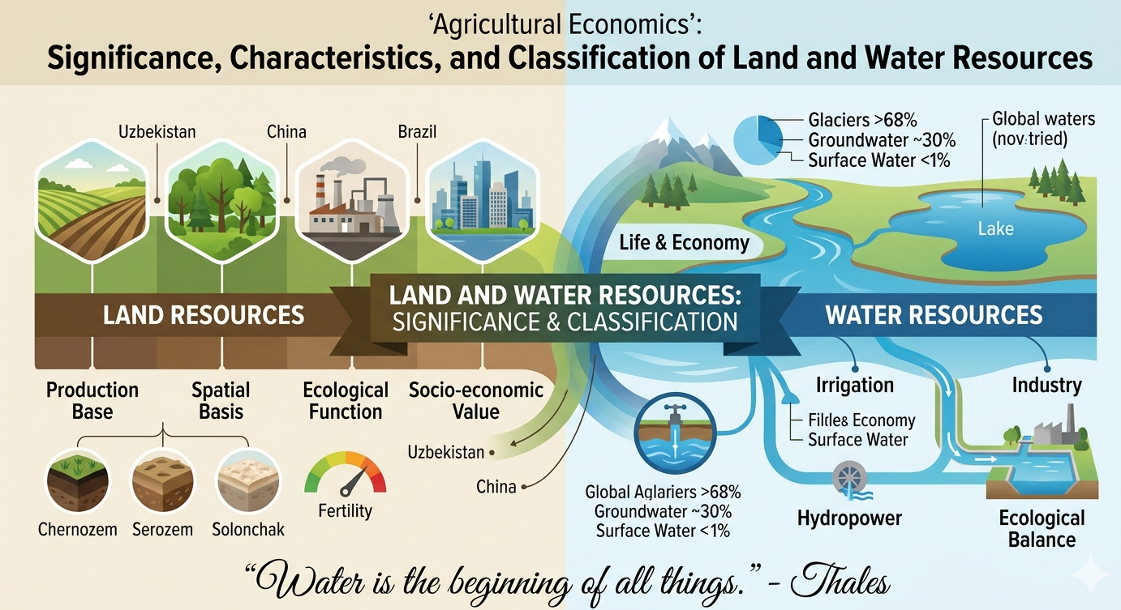

Significance of Land and Water Resources:
- Production base of agriculture: Land and water are indispensable for crop cultivation, livestock breeding, and food security.
- Spatial basis for infrastructure: Land provides the physical space for cities, transport networks, and industrial zones.
- Ecological function: Supporting biodiversity, climate regulation, and ecosystem preservation.
- Socio-economic value: A fundamental source of income, investment, employment, and societal well-being.

Key Characteristics of Land:
- Area: The total territory available and suitable for use.
- Fertility: The content of humus and essential nutrients in the soil.
- Type of land use: Agricultural land, forests, pastures, urbanized areas, etc.
- Legal status: State, private, or collective ownership.

Natural and Geographical Zones of Uzbekistan:
- Sandy deserts: (e.g., the Kyzylkum Desert).
- Gypsum-gravel and clay deserts: (e.g., takyrs).
- Salt marshes / Solonchak lands: (e.g., Barsakelmes).
- Mountain and foothill ecosystems: (e.g., Tian Shan, Hisar ranges).
- Tugai forests and wetlands: (e.g., river valleys of the Amu Darya and Syr Darya).

Classification of Land by Purpose:
Land Type | Intended Purpose | Example
Agricultural | Crop production, livestock farming | Rice paddies in China
Forestry | Timber production, ecological balance | The Amazon rainforest, Russian taiga
Industrial | Factories, manufacturing, infrastructure | Germany, South Korea
Settlements | Urban and rural residential development | Tashkent, Tokyo
Water Fund | Rivers, lakes, reservoirs, canals | The Amu Darya River, Lake Baikal
Reserve Land | Unused or vacant land | Deserts of Australia
The ecological map illustrates the distribution of various landscape types across the country. Below is a detailed description of each zone:
- Sandy deserts: Occupy most of Uzbekistan's territory, particularly in the central region. The most famous is the Kyzylkum Desert. Sandy dunes and barkhans predominate here. The soils are gray-brown desert soils, and vegetation is sparse and drought-resistant.
- Gypsum-gravel desert: Characterized by a stony, gravelly surface containing high amounts of gypsum.
- Clay desert: These deserts (takyrs) form on clayey soils, which develop a hard, cracked crust after seasonal rains dry up.
- Salt marsh (Solonchak) desert: Found in low-lying relief areas where intensive soil salinization occurs. They feature a high concentration of toxic salts. A vivid example is the Barsakelmes salt flat in Karakalpakstan.
- Mountain and foothill ecosystems: Located in the east and southeast of the country, encompassing the spurs of the Tian Shan and Hisar ranges. These landscapes exhibit rich diversity and altitudinal zonation. Foothills feature ephemeral vegetation on serozem (gray) soils, shifting higher up to mountain forests, shrubs, alpine meadows, and mountain steppes.
- Tugai: Riparian forests that grow exclusively along the banks of rivers in Central Asia.
- Wetlands: Located in river deltas and around lakes, particularly near the Aral Sea region, though they have undergone severe degradation due to acute water shortages.
- River valley ecosystems: Fertile lands stretching along the Amu Darya and Syr Darya rivers, where population centers and highly developed agriculture are concentrated. Broadly dominated by meadow-takyr soils.

Water Resources
Water is a critical resource for life and the economy. Without it, agriculture, industry, and ecological sustainability are impossible.
"Water is the first principle of everything."
— Thales of Miletus (Ancient Greek philosopher, considered the first scientist in the Western tradition)
This statement by Thales means that water is the primordial substance (the first element) from which the entire world is constituted. Its essence lies in:
- The search for a primary cause: It was the first historical attempt to explain the structure of the cosmos rationally, without relying on myths or gods.
- Observation of living things: Thales observed that the life and growth of all plants and animals depend strictly on water.
- Transition of states: Water can be liquid, solid (ice), and gaseous (vapor), demonstrating a visible capacity to transform into different physical states of matter.

Types of Water Resources:
Type of Water Resource | Example | Primary Use
Surface Water | Rivers, lakes | Irrigation, hydropower, transport
Groundwater | Artesian wells | Drinking water supply, industrial processes
Artificial Bodies | Canals, reservoirs | Crop irrigation, flow regulation, hydropower

Global Context:
- More than 68% of the Earth's freshwater is locked up in glaciers and ice caps.
- Groundwater accounts for roughly 30% of all freshwater resources.
- Rivers and lakes make up less than 1% of global freshwater supplies.
Access to clean water is turning into a critical factor for national security and economic development, particularly across arid regions and booming megacities.
- Land is not merely a surface for farming or constructing buildings. It is a complex resource that encompasses the fertile soil layer, minerals, structure, and chemical composition, all of which dictate its ultimate productivity.
- Water is a vital resource necessary for the survival of all living organisms, as well as for industrial, agricultural, and domestic consumption.
Example Case:
A 100-hectare plot of land is located in Uzbekistan, out of which 70 hectares are highly suitable for growing cotton. The nearby Amu Darya River provides irrigation.
- Land resource: Arable, fertile soil; 70 hectares available for agriculture.
- Water resource: The Amu Darya River, ensuring continuous irrigation.

2. State Land Cadastre and Land Monitoring

What is a Cadastre?
The State Land Cadastre is a systematized database containing verified information about the country's land resources. It includes:
- Precise location and geographic coordinates/boundaries of land parcels.
- The category and specific designation of land use (agricultural, forestry, industrial, urban).
- Legal status and ownership details (state, private, collective).
- Quality, composition, and characteristics of the soil.
- Economic appraisal and potential yield/profitability of the land plot.

Purpose of the Cadastre:
- Monitoring the rational and lawful use of land resources.
- Strategic planning of agriculture, heavy industry, and national infrastructure.
- Attracting foreign investments and enabling agricultural credit/banking.
- Protecting property rights and settling land disputes.

Global Best Practices:
- USA: Employs advanced GIS (Geographic Information Systems) and cloud-based electronic cadastral maps to track every plot and its changes in real time.
- Germany: Actively monitors soil quality and land health to ensure long-term sustainable land management.
- China: Operates a centralized land database to control agricultural zoning and guarantee optimized land distribution for national grain production.

Land Monitoring
Land monitoring is a structured system of continuous observations of the state of land resources designed to detect negative changes early, prevent degradation, and secure rational land use.
Global Example:
In Australia, systematic land monitoring allows authorities to track soil salinization and prevent the loss of fertile pasturelands, which is critical for their large-scale grain and livestock industries.

Core Areas of Land Monitoring:
Type of Monitoring | Inspected Factors | Methods & Tools | Global Example
Agroecological | Soil fertility, erosion, salinization rates | Soil sampling, chemical analysis, field surveys | France: Conducts regular soil testing across commercial farmlands.
Geoinformation | Area changes, land-use shifts, degradation | GIS, satellite imagery, remote sensing drones | USA: Satellite-driven tracking of land cover and parcel modifications.
Economic | Profitability, structural economic efficiency | Statistical tracking, economic analytical reports | China: Tracks the fiscal yield of agricultural lands down to the provincial level.

3. Economic Evaluation of Land in Agriculture

Core Concept
The economic evaluation of land is a method used to determine the monetary value of land based on its actual productivity, profitability, and potential use.
It allows stakeholders to:
- Determine how effectively a given plot of land is being utilized.
- Plan capital investments in agribusiness.
- Provide credit and loans to farmers and agricultural enterprises.
- Forecast total yields and ensure long-term food security.

Global Context:
- In countries like Japan and South Korea, where arable land is extremely scarce, precision economic evaluation is imperative to maximize crop yields.
- In developing economies (e.g., across parts of Africa or South Asia), land valuation helps attract foreign agricultural investments, modernize technologies, and boost farm incomes.
- In land-abundant countries (e.g., Brazil or the USA), evaluation is heavily used for zoning laws and preventing the wasteful exploitation of natural resources.

Comparison of Soil Types in Uzbekistan:

Soil Type | Average Yield (centners/ha) | Net Revenue (UZS/ha) | Economic Rating
Alluvial-Oasis Soil (Fergana Valley) | 35 | 3,000,000 | High
Serozem / Gray Soil (Kashkadarya, Surkhandarya) | 28 | 2,100,000 | Medium
Solonchak / Salt Marsh (Navoiy Region) | 18 | 1,000,000 | Low
The most productive lands are situated within the Fergana and Zarafshan valleys, benefit from well-developed irrigation, and possess naturally superior soil fertility.

Global and National Priorities:
- Intensive Land Use: In Uzbekistan, where every arable hectare is invaluable, modern drip irrigation and digital soil monitoring are being rolled out. This drives yields up without requiring spatial expansion.
- Economic Appraisal & Cadastre: The national land cadastre is updated using GIS and satellite tracking, ensuring fair government subsidies and strict soil quality control.
- Sustainable Land Management: The primary challenge is preventing extensive soil salinization and desertification, notably in the arid zones of Karakalpakstan and the Bukhara region.

Practical Section: Case Studies and Exercises

Case Study 1: Farm Planning
Baseline Data:
Soil Type | Yield (centners/ha) | Price per 1 centner (UZS) | Production Cost (UZS/ha)
Chernozem | 60 | 250,000 | 5,000,000
Serozem | 45 | 250,000 | 3,500,000
Sandy Soil | 25 | 250,000 | 1,500,000

Case Study 2: Land Monitoring Crisis
Scenario: In an agricultural province with 3 rivers and 2 major reservoirs, land monitoring reports for 2024 revealed a 10% increase in soil salinization alongside a 15% decrease in available water levels.

Case Questions:
- What targeted counter-measures can be proposed to restore soil health and optimize water resources?
- How does timely land monitoring prevent severe crop failures and loss of regional farm income?
- What advanced global monitoring technologies should be deployed in this specific region?

Review Questions for Knowledge Retention
- Define the State Land Cadastre and explain its structural importance to national economic planning.
- Outline the three main branches/dimensions of land monitoring.
- What is the fundamental goal of the economic evaluation of agricultural lands?
- How does soil quality directly influence the final profitability of a farming enterprise?
- Provide examples of countries operating under severe land and water resource constraints, and explain how they maintain national food security.

Bibliography / References
- Karimov, A. Kh. Land Resources and Their Rational Use under the Conditions of Uzbekistan. — Tashkent: Fan, 2020. — 310 p.
(A textbook analyzing the economic and ecological dimensions of sustainable land management across Uzbekistan's agrarian regions).
- Nurmatova, D. B. Methodology for the Economic Evaluation of Arable Lands in the Agriculture of Uzbekistan. — Samarkand: SamISI, 2019. — 280 p.
(This book outlines calculations for land efficiency alongside practical frameworks for augmenting agricultural yields).
- International Bank for Reconstruction and Development (World Bank). Land and Water Resources Management: Global Perspectives. — 2023.
URL: https://www.worldbank.org/en/topic/landmanagement
- FAO (Food and Agriculture Organization of the UN). The State of the World’s Land and Water Resources for Food and Agriculture (SOLAW). — 2022.
URL: http://www.fao.org/land-water/en/
(Global datasets and analytical assessments focusing on land-water dynamics relative to international food security).
- State Land Cadastre of the Republic of Uzbekistan. Methodological Guidelines for the Monitoring and Accounting of Lands. — Tashkent, 2021.
(Regulatory manual detailing the regional technical parameters of cadastral registration within Uzbekistan).
- Zhang, L., Li, X. GIS and Remote Sensing Applications in Land Monitoring. — Springer, 2020.
(Academic text on using geographic information systems and satellite remote sensing for ecological monitoring).
- OECD (Organisation for Economic Co-operation and Development). Agricultural Policy Monitoring and Evaluation 2024.
URL: https://www.oecd.org/agriculture/
(Global policy report reviewing structural changes in international agricultural performance).
- Harford, T. The Undercover Economist. — Little, Brown, 2006.
(An introduction to understanding the economic scarcity and value of natural resources).
- Schmidhuber, J., Tubiello, F. N. Global Food Security under Climate Change. // Food Policy Journal, 2022.
(An article assessing the impacts of volatile climate patterns on regional agricultural sustainability).
- Collected Statutory Documents of the Republic of Uzbekistan:
Law of the Republic of Uzbekistan "On the State Land Cadastre" (Amended 2020).
Decrees of the Cabinet of Ministers on the systems for land monitoring and national resource accounting.

