Ministry of Higher Education, Science and Innovation of the Republic of Uzbekistan
Gulistan State University



Agrochemistry 2nd level 60810200 – Short lecture course for students of the Agrochemistry and Soil Science education program (content)

Author: Turdimetov Shakhobiddin Mukhitdinovich, Professor of the Department of Agrosoilscince and Land Reclamation of GulSU, DSc

Reviewer: PhD, Associate Professor I.A.Rakhmonov

Gulistan-2025

Agrochemistry 2nd stage 60810200-Agrochemistry and Soil Science 2nd year students short lecture course (content)
Annotation

Author : Turdimetov Shaxobiddin Mukhitdinovich Department of Agrosoilscince and Land Reclamation of GulSU, DSc, 2025

This is a short course of lectures. The 2nd year of the Agrochemistry course 60810200-Agrochemistry and Soil Science was developed for 2nd year students based on the qualification requirements of this course.
Covered the topic "The Importance of Phosphorus in Plant Life" in the field of "Agrochemistry".
Plants in this lecture course in life phosphorus Importance of plants​ phosphorus sources. Soil by edible exchangeable phosphate acid anions. In soils phosphorus amount and forms. In the soil phosphorus plants​ by In industry​​ working removable phosphorous fertilizers. Phosphorus​ fertilizers efficiency increase Information is provided on.

" Phosphorus" plants in life role . Phosphorus fertilizers ” topic according to contents for free copy to take "Soil water regime and methods of its management"

A brief history of early phosphorus research
Dr. John Mitchell at the University of Saskatchewan recorded the first crop response to phosphorus in Western Canada in 1927. His groundbreaking research with radioactive-marked phosphorus fertilizer continued for nearly 20 years, with four main conclusions, which remain the pillars for phosphorus fertilizer management today:
- Western Canadian soils are naturally deficient in phosphorus
- Monoammonium phosphate (such as 11-52-0) is the best form of phosphorus fertilizer for most Canadian soils
- In addition to large yield responses, phosphorus is critical to ensure early maturity of crops in a short growing season
- Crops cannot use a large portion of phosphorus fertilizer applied each year, but can use residual phosphorus from fertilizer applied in previous years
Phosphorus fertilizer application became common practice on farms by the 1940s, and research continued to sort out best phosphorus fertilizer management. Yield responses in this early research averaged over five bushels per acre in wheat, with the largest responses in moist environments, clay soils, and on fallow.
More recent field research has measured smaller yield responses to phosphorus fertilizer. When phosphorus fertilizer is applied each year, a small pool of residual available phosphates can partly supply subsequent crops, and the apparent annual phosphorus response for these soils is reduced. As demonstrated by Dr. Mitchell’s research, phosphorus must be managed as a residual nutrient due to the low solubility of all phosphorus fertilizers. This small bank of soil phosphorus requires replacement each year to account for crop removal.
Plants use high-energy phosphate bonds to store energy gained from photosynthesis for growth and development of plant cells. This energy is especially critical during rapid growth of seedlings, and for seed formation. When energy for growth or seed production is required, these bonds are broken, and the stored energy is released.
If phosphorus is deficient, crop development and maturity are delayed. This is particularly true during the early development of the seedling. For this reason, farmers often notice a ‘pop-up’ effect of vigorous seedling growth when phosphorus is applied. In most years delayed growth may not affect crop yield. However, delayed crop maturity in some years may devastate crop yield and quality due to fall frosts. If phosphorus deficiency is very severe the plant tissue will appear purple, especially on older leaves. Be careful with this symptom though, as normal genetics, cold damage, and herbicide injury can also cause a plant to be purple.
A final important benefit of adequate phosphorus nutrition is protection from plant disease. Plants that develop slowly provide a larger window for disease infection. Before application of phosphorus fertilizer became routine in Canada, cereal crops were often severely infected by root rot fungi. With the introduction of phosphorus fertilizers, cereal seedlings developed a strong root system quickly and were less susceptible to root rot.

ESSENTIAL ROLE OF PHOSPHORUS IN PLANTS
Phosphorus is an essential nutrient both as a part of several key plant structural compounds and as a catalyst in the conversion of numerous key biochemical reactions in plants. Phosphorus is noted especially for its role in capturing and converting the sun's energy into useful plant compounds.
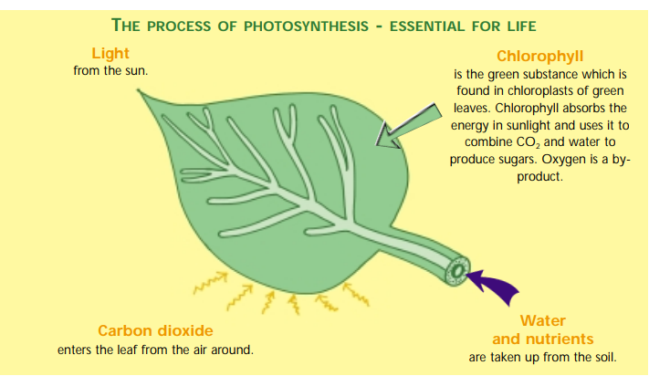

Phosphorus is a vital component of DNA, the genetic "memory unit" of all living things. It is also a component of RNA, the compound that reads the DNA genetic code to build proteins and other compounds essential for plant structure, seed yield and genetic transfer. The structures of both DNA and RNA are linked together by phosphorus bonds.
Phosphorus is a vital component of ATP, the "energy unit" of plants. ATP forms during photosynthesis, has phosphorus in its structure, and processes from the beginning of seedling growth through to the formation of grain and maturity.
Thus, phosphorus is essential for the general health and vigor of all plants. Some specific growth factors that have been associated with phosphorus are:
- Stimulated root development
- Increased stalk and stem strength
- Improved flower formation and seed production
- More uniform and earlier crop maturity
- Increased nitrogen N-fixing capacity of legumes
- Improvements in crop quality
- Increased resistance to plant diseases
- Supports development throughout the entire life cycle
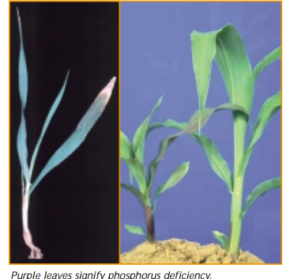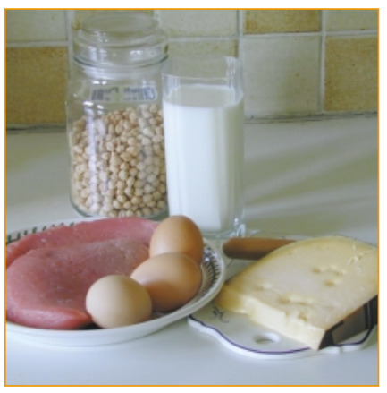

PHOSPHORUS DEFICIENCY IN PLANTS
Phosphorus deficiency is more difficult to diagnose than a deficiency of nitrogen or potassium. Crops usually display no obvious symptoms of phosphorus deficiency other than a general stunting of the plant during early growth. By the time a visual deficiency is recognized, it may be too late to correct in annual crops. Some crops, such as corn, tend to show an abnormal discoloration when phosphorus is deficient. The plants are usually dark bluish-green in color with leaves and stem becoming purplish. The degree of purple is influenced by the genetic makeup of the plant, with some hybrids showing much greater discoloration than others. The purple color is due to accumulation of sugars that favors the synthesis of anthocyanin (a purple-colored pigment), which occurs in the leaves of the plant.
Phosphorus is highly mobile in plants, and when deficient, it may be translocated from old plant tissue to young, actively growing areas. Consequently, early vegetative responses to phosphorus are often observed. As a plant matures, phosphorus is translocated into the fruiting areas of the plant, where high-energy requirements are needed for the formation of seeds and fruit. Phosphorus deficiencies late in the growing season affect both seed development and normal crop maturity. The percentage of the total amount of each nutrient taken up is higher for phosphorus late in the growing season than for either nitrogen or potassium.

SYMPTOMS IN CORN
The photo at left shows a P deficient corn plant. Older leaves are affected before younger ones because of the redistribution of P in the plant. Corn may display a purple or reddish color on the lower leaves and stems. This condition is associated with accumulation of sugars in P-deficient plants, especially during times of low temperature.
All photos are provided courtesy of the International Plant Nutrition Institute (IPNI) and its Crop Nutrient Deficiency Image Collection. The photos above are a sample of a larger collection, which provides a comprehensive sampling of hundreds of classic cases of crop deficiency from research plots and farm fields located around the world. For access to the full collection, you can visit IPNI's website.

PHOSPHORUS IN SOILS
The total phosphorus content of most surface soils is low, averaging only 0.6% phosphorus. This compares to an average soil content of 0.14% nitrogen and 0.83% potassium. The phosphorus content of soils is quite variable, ranging from less than 0.04% P₂O₅ in the sandy soils of the Atlantic and Gulf coastal plains to more than 0.3% in the soils of the northwestern United States.
Many factors influence the content of soil phosphorus:
Type of parent material from which the soil is derived
Degree of weathering and erosion
Climatic conditions
Crop removal and fertilization

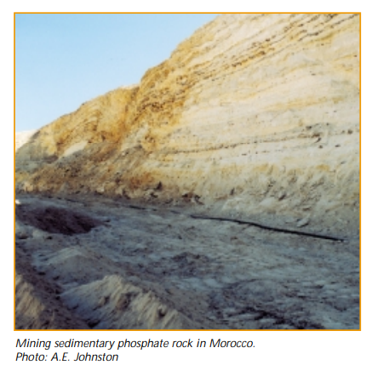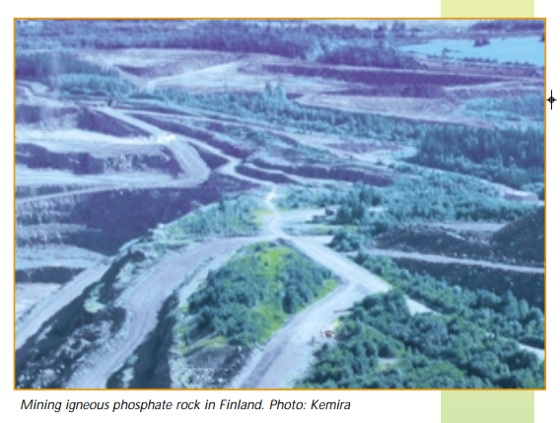

ORGANIC PHOSPHORUS
Soil phosphorus is classified into two broad groups, organic and inorganic. Organic phosphorus is found in plant residues, manures and microbial tissues. Soils low in organic matter may contain only 3% of their total phosphorus in the organic form, but high-organic-matter soils may contain 50% or more of their total phosphorus content in the organic form.

INORGANIC PHOSPHORUS
Inorganic forms of soil phosphorus consist of apatite (the original source of all phosphorus), complexes of iron and aluminum phosphates, and phosphorus absorbed onto clay particles. The solubility of these phosphorus compounds as well as organic phosphorus is extremely low, and only very small amounts of soil phosphorus are in solution at any one time. Most soils contain less than a pound per acre of soluble phosphorus, with some soils containing considerably less.
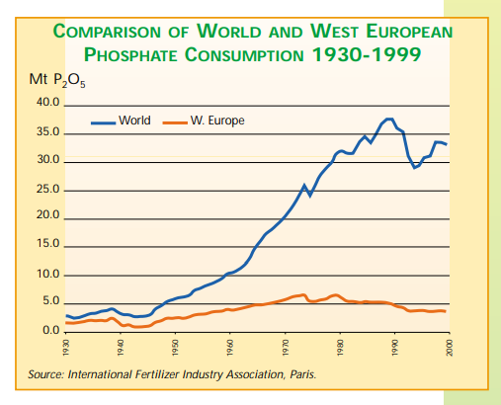

Through adequate phosphorus fertilization and good crop/soil management, soil solution phosphorus can be replaced quickly enough for optimum crop production.

SOIL PHOSPHORUS AVAILABILITY
Soluble phosphorus, either from fertilizer or natural weathering, reacts with clay, iron and aluminum compounds in the soil, and is converted readily to less available forms by the process of phosphorus fixation. Because of these fixation processes, phosphorus moves very little in most soils (less than an inch), stays close to its place of origin, and crops rarely absorb more than 20 percent of fertilizer phosphorus during the first cropping season after application. As a result, little soil phosphorus is lost by leaching. This fixed, residual phosphorus remains in the rooting zone and will be slowly available to succeeding crops. Soil erosion and crop removal are the significant ways soil phosphorus is lost.

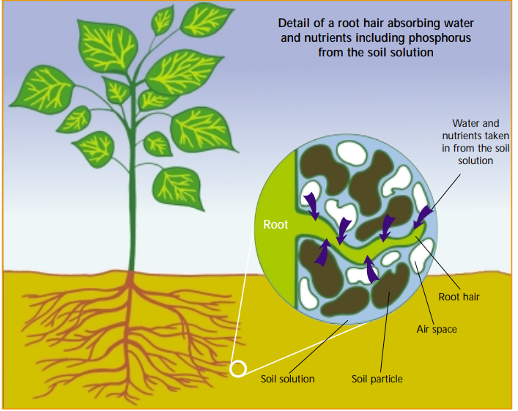

FACTORS OF PHOSPHORUS AVAILABILITY
SOIL pH
Precipitation of phosphorus as slightly soluble calcium phosphates occurs in calcareous soils with pH values around 8.0. Under acid conditions, phosphorus is precipitated as Fe or Al phosphates of low solubility. Maximum availability of phosphorus generally occurs in a pH range of 6.0 to 7.0. This is one of the beneficial effects of liming acid soils. Maintaining a soil pH in this range also favors the presence of H₂PO₄⁻ ions, which are more readily absorbed by the plant than HPO₄⁺ ions, which occur at pH values above 7.0.

ADVANCED CROP NUTRITION
Adequate supplies of other plant nutrients tend to increase the absorption of phosphorus from the soil. Application of ammonium forms of nitrogen with phosphorus increases phosphorus uptake from a fertilizer as compared to applying the phosphorus fertilizer alone or applying the nitrogen and phosphorus fertilizers separately. Applications of sulfur often increase the availability of soil phosphorus on neutral or basic soils, where the soil phosphorus is present as calcium phosphates.

ORGANIC MATTER
Soils high in organic matter contain considerable amounts of organic phosphorus that are mineralized (similar to organic nitrogen), and provide available phosphorus for plant growth. In addition to supplying phosphorus, organic matter also acts as a chelating agent and combines with iron, thereby preventing the formation of insoluble iron phosphates. Heavy applications of organic materials such as manure, plant residues or green manure crops to soils with high pH values not only supply phosphorus, but upon decomposition, provide acidic compounds, which increase the availability of mineral forms of phosphorus in the soil.

TYPE OF CLAY
Clay particles tend to retain or fix phosphorus in soils. Consequently, fine-textured soils such as clay loam soils have a greater phosphorus-fixing capacity than sandy, coarse-textured soils. Clays of the 1:1-type (kaolinite) have a greater phosphorus-fixing capacity than the 2:1-type clays (montmorillonite, illite , vermiculite). Soils formed under high rainfall and high temperatures contain large amounts of kaolinitic clays, and therefore have a much greater fixing capacity for phosphorus than soils containing the 2:1-type clay. High temperatures and high rainfall also increase the amount of iron and aluminum oxides in the soil, which contributes greatly to the fixation of phosphorus added to these soils.

APPLICATION TIMING
Fixation of soil phosphorus increases with time of contact between soluble phosphorus and soil particles. Consequently, more efficient utilization of fertilizer phosphorus is generally obtained by applying the fertilizer shortly before planting the crop. This practice is especially effective on soils with high phosphorus-fixing capacities. On coastal plain areas, fertilizers may be applied several months before planting with little or no decrease in availability of the fertilizer phosphorus to the crop. Banding of fertilizer for row crops is also much more likely to increase the efficiency of fertilizer phosphorus on soils of high phosphorus-fixing capacity than on soils of low phosphorus-fixing capacity.

SOIL TEMPERATURE/AERATION/MOISTURE AND COMPACTION
Phosphorus absorption by the plant is decreased by low soil temperature and poor soil aeration. Starter fertilizers containing water-soluble phosphorus are much more likely to increase crop growth during cool weather. Excessive soil moisture or soil compaction reduces the soil oxygen supply and decreases the ability of the plant roots to absorb soil phosphorus. Compaction reduces aeration and pore space in the root zone. This reduces phosphorus uptake and plant growth. Compaction also decreases the soil volume that plant roots penetrate, limiting their total access to soil phosphorus.

SOIL TEST PHOSPHORUS LEVELS
Crop responses to fertilizer phosphorus will be greater and occur more frequently on soils testing low in phosphorus than on high-testing soils. However, yields on soils with high P soil test levels are usually higher. The response to phosphorus fertilizer on high-testing soils is increasing, and it is important to maintain high soil phosphorus levels to support optimum crop production.

PHOSPHORUS PLACEMENT
If a grower is looking for maximum return from high phosphorus investment on low-testing soils, band application is best. Where conservation tillage is practiced, combinations of band and broadcast applications of phosphorus may be needed. This ensures an early, accessible phosphorus supply for developing seedlings and a nutrient reserve later in the growing season, when phosphorus demands remain strong.

ADVANTAGES OF BROADCAST/PLOW-DOWN PHOSPHORUS APPLICATIONS
High rates can be applied without injuring the plant
Nutrient distribution throughout the root zone encourages deeper rooting, while band placement causes root concentration around the band
Deeper rooting permits more root-soil contact, providing a larger reservoir of moisture and nutrients
Practical way to apply fertilizer to forages
Helps ensure full-feed fertility to help the crop take full advantage of favorable growth conditions throughout the growing season
Dual application of anhydrous ammonia and ammonium polyphosphates at seeding of wheat has been found to be superior to broadcast or band applications of ammonium polyphosphates.

Placement directly under the drill row (band seeding) for forage crops has proven superior to broadcast or side placement.

The Benefits of Triple Phosphate Fertilizer
Triple phosphate fertilizer, commonly known as triple superphosphate (TSP), is one of the first high-analysis phosphorus fertilizers. It is a very common fertilizer for promoting plant wellness and is often used for fertilizing leguminous crops, like beans or alfalfa, since they do not require nitrogen fertilization. If you want your plants to be happy and healthy, you can trust Easy Peasy Plants for all of your fertilizer needs! Let's take a look at the advantages of triple phosphate fertilizer!

Root Growth
Roots are the foundation of every plant. Having a healthy root system is vital to ensure the wellness of any plant. Phosphorus is a crucial nutrient for encouraging root growth and ensuring a robust and web-like root system. It also improves the absorption of other nutrients.

Enhanced Resilience
TSP enhances the strength and resilience of a plant. It makes the plant better prepared to ward off diseases and increases the resistance of the plant against freezing, preparing them for the winter season.

Improved Flowers and Seeds
Whether you are a homeowner or a landscaper, paying attention to the flower formation is crucial. Moreover, flower formation is one of the top indicators of a healthy fruit set. Ensuring that your plants get the right amount of TSP goes a long way in enhancing flower formation and boosting seed production.

Abundance of Nutrients
TSP contains the highest phosphorus content among nitrogen-free dry fertilizers. Additionally, more than 90% of the total phosphorus in TSP is water-soluble so that the plants can absorb its nutrients quickly. TSP also contains 15% calcium, supplying yet another nutrient to the plants.
Triple phosphate fertilizer has been around for decades now. It is, without a doubt, one of the best phosphate fertilizers. It is especially advantageous in the case of plants that do not need nitrogen fertilization to supplement the biological nitrogen fixation process. If you want to know whether TSP is the best product for your plants or not, contact Easy Peasy Plants, and we will help you out!

The Function Of Phosphorus In Plants And The Garden
The function of phosphorus in plants is very important. It helps a plant convert other nutrients into usable building blocks with which to grow. Phosphorus is one of the main three nutrients most commonly found in fertilizers and is the "P" in the NPK balance that is listed on fertilizers. Phosphorus is essential to a plant's growth, but what does it mean if you have high phosphorus in your soil, or a phosphorus deficiency? Keep reading to learn more about the importance of phosphorus in plant growth.

Phosphorus Deficiency in the Soil
How can you tell if your garden has a phosphorus deficiency? The easiest way to tell is to look at the plants. If your plants are small, are producing little or no flowers, have weak root systems or a bright green or purple cast, you have a phosphorus deficiency. Since most plants in the garden are grown for their flowers or fruit, replacing phosphorus in the soil if it is lacking is very important.
There are many chemical fertilizers that can help you replace phosphorus and get a good nutrient balance in your soil. When using chemical fertilizers, you will want to look for fertilizers that have a high "P" value (the second number in the fertilizer rating NPK).
If you would like to correct your soil's phosphorus deficiency using organic fertilizer, try using bone meal or rock phosphate. These both can help with replacing phosphorus in the soil. Sometimes, simply adding compost to the soil can help plants be better able to take up the phosphorus that is already in the soil, so consider trying that before you add anything else.
Regardless of how you go about replacing phosphorus in the soil, be sure not to overdo it. Extra phosphorus can run off into the water supply and become a major pollutant.

High Phosphorus in Your Soil
It's very difficult for a plant to get too much phosphorus due to the fact that it's difficult for plants to absorb phosphorus in the first place.
There is no understating the importance of phosphorus in plant growth. Without it, a plant simply cannot be healthy. The basic function of phosphorus makes it possible to have beautiful and abundant plants in our gardens.
Since its establishment, our company has obtained authoritative certifications such as SGS and CE and has highly qualified R&D management and production staff. Our main products are bulk phosphate fertilizer , single superphosphate fertilizer , granular nitrogen fertilizer , npk fertilizer manufacturer , npk fertilizer factory , npk compound fertilizer supplier , and so on. The factory insists on the principle of quality first and has been developing world-class products. Under the effective operation of the quality assurance system, the quality of products and processed products have been continuously improved. Our products have earned a good reputation in the industry and have gained valuable trust among new and existing customers. Our products are sold well at home and abroad, including in Europe, America, Southeast Asia, the Middle East and other countries and regions. We pay more attention to the principle of honest management and mutual benefit

Questions and assignments
- In what forms does phosphorus occur in plants?
- In what processes in the plant body does phosphorus actively participate?
- Which plants can also absorb poorly soluble phosphorus compounds in the soil?
- What are apatites and phosphorites, their similar and differentiating features.
- What groups can phosphorus fertilizers be divided into according to their solubility?
- Explain the method of obtaining superphosphate. What is the difference between simple and double superphosphate?
- Describe phosphorus fertilizers soluble in weak acids.
- What is the effectiveness of incorporating phosphorus fertilizers into the main fertilization process?

Test questions

1. What is the amount of phosphorus in superphosphate?
A. 19-22%
B. 5-10%
C. 30-40%
D. 70-80%
2. What are the positive aspects of superphosphate?
A. lack of gypsum in the composition
B. lack of P2O5 in the composition
C. low hygroscopicity
D. Alkalinity
3. Which organic matter is most abundant in legumes?
A. Oxyl
B. Shoulder bag
C. Carbon
D. Glucose
4. How much phosphorus is in a ton of manure?
A. 10
B. 20
C. 24
D. 28
5. Identify mineral fertilizers
A. KSL
B. NaCl
C. BaCl2
D. HCl
6. Identify the most common nutrients in gray soils?
A. Potassium
B. Phosphorus
C. Nitrate
D. Azot
7. The scientist who created the scheme of the mutual relationship between fertilizer, plants and soil
A. Pryanishnikov
B. Lomonosov
C. Mendeleev
D. Boyle
8. Mark the row with the macroelements given
A. S, O, R, K, N, N
B. Cu, Mg, V
C. Ru, Sc, Ag
D. Ca, Hg, Cu
9. What are the elements that remain when plants are burned called?
A. Ash elements
B. Microelements
C. Macroelements
D. Ultramicroelements
10. Elements that make up a very small part of the plant body
A. Ultramicroelements
B. Ash elements
C. Microelements
D. Macroelements
11. What substances make up 80-90% of the dry mass of a plant?
A. Organic matter
B. Inorganic substances
C. Lipids
D. Proteins
12. Mark the row where organic substances are given.
A. Protein, fat, lipid
B. Starch, water, oil
C. Protein, salt, lipid
D. Water and salt
13. The most common organic substances in plants
A. Carbohydrates, fats, and proteins
B. Water, starch, lipid
C. Protein, fat, lipid
D. Starch, water, oil
14. If the soil contains 15 mg/kg of mobile phosphorus, when should phosphorus fertilizers be applied to cotton?
A. Before plowing, during planting, during flowering.
B. At the beginning of labor;
C. In Shonalash;
D. In bloom;
15. What type of phosphorus fertilizer gives the best results when applied to gray soil during autumn plowing?
A. superphosphate;
B. precipitate;
C. Thomas Slag;
D. Phosphorite flour;

GLOSSARY

1 | White phosphorus | – a solid substance obtained by rapidly cooling phosphorus vapor.
2 | Red phosphorus | It is formed by prolonged heating of white phosphorus in the absence of air at temperatures of 250–300°C. It has a reddish-violet color.
3 | Black phosphorus | It is obtained from white phosphorus by heating to 200–220°C under high pressure. It is similar in appearance to graphite and has a greasy feel.
4 | Calcium orthophosphate | Ca₃(PO₄)₂. The most important phosphorus compound in nature. It forms large deposits as phosphorite.
5 | Total phosphorus | It consists of organic and mineral compounds. Its total content depends on the soil's particle size distribution, its degree of cultivation, the characteristics of the parent rock, and its genesis.
6 | Organic phosphates | It is found primarily in humus. Some organic phosphorus is present in phytin, phosphatides, nucleic acids, and other organic soil compounds.
7 | Phosphatides | It is an ester of glycerol, high-molecular-weight fatty acids, and phosphoric acid. They are components of phospholipid membranes and regulate the permeability of cellular organelles and the plasma membrane to various substances.
8 | Main functions of phosphorus | Most phosphorus is present in the reproductive organs and young parts of plants. Phosphorus is responsible for accelerating the development of plant root systems.

Home literature :
- Yagodin BA, Zhukov YP, Kobzarenko VI Agrochemistry / Edited by BA Yagodin. - Moscow: Kolos, 2002. - 584 p.: ill.
- Evtefeev YV, Kazantsev GM, Bases of agronomy: textbook. - M.: FORUM, 2013. - 368 p.: ill.
- Agrochemistry . Textbook / VG Mineev , VG Sychev, GP Gamzikov et al. - Moscow: Publishing house of the All-Russian Scientific Research Institute named after DN Pryanishnikov, 2017. - 854 p .

Additional literature :
- (2022) USDA National Organic Program. Standard manual. CCOF certification services LLC, Santa Cruz, California, USA.
- Soni R, Yadav SK (2019) Prospect of organic farming as financial sustainable strategy in modern agriculture. In: Panpatte DG, Jhala YK, (Eds.), Soil fertility management for sustainable development, Springer Nature Singapore Private Limited, Singapore, pp. 251-2665.
- Huang R, Hue N (2022) In transition towards organic farming: Effects of rock phosphate, coral lime, and green manure on soil fertility of an acid Oxisol and the growth of soybean (Glycine max L. Merr .) seedlings. Agriculture 12(12): 2045.
- Sanchez P (2019) Properties and management of soils in the Tropics. (2nd edn ), Chapter 14, Ph

Internet resource
- https://universityagro.ru/en/agrochemistry/phosphorus-in-plant-life/
- https://www.researchgate.net/publication/289790667_Phosphorus_in_agriculture_Problems_and_solutions
- https://link.springer.com/chapter/10.1007/978-981-10-9044-8_7
- https://www.hans-chem.com/the-role-of-phosphorus-fertilizers-in-agriculture/
- https://brandteurope.com/en/the-importance-of-phosphorus-in-agriculture-essential-nutrients/
- https://crimsonpublishers.com/mcda/pdf/MCDA.000820.pdf
- https://loyalfertilizer.com/blog/phosphorus-organic-fertilizer/
- https://grow.ifa.coop/agronomy/phosphorus-role-in-plant-growth-productivity

